1)Create VPC

Prerequisites
Before starting, install:
- Terraform
- Amazon Web Services CLI
- AWS Account

Step 1.1 — Create Project Folder
Open terminal and create a folder.
mkdir terraform-vpc-project
cd terraform-vpc-project
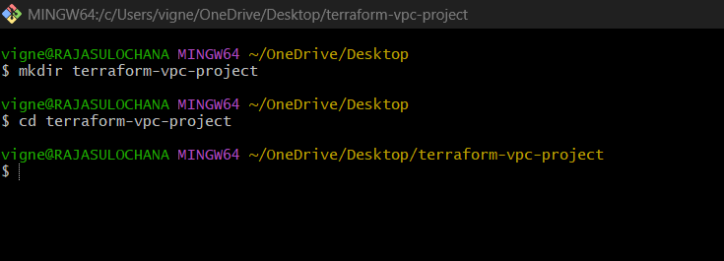
Check current path:
Pwd
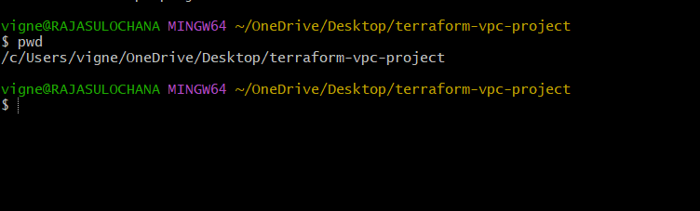

Step 1.2 — Create provider.tf
Create file:
touch provider.tf
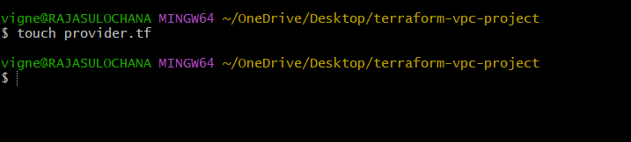
Open file using VS Code:
code provider.tf
Add this code:
nano provider.tf
terraform {
required_providers {
aws = {
source = "hashicorp/aws"
version = "~> 5.0"
}
}
}
provider "aws" {
region = "eu-north-1"
}
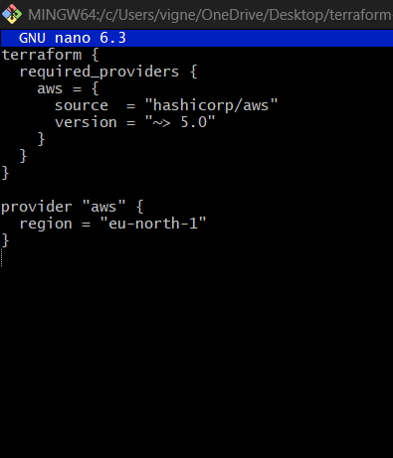

Explanation
terraform block
Used to define required providers.
terraform {

required_providers
Tells Terraform which provider is needed.
required_providers

aws provider
Downloads AWS plugin from HashiCorp.
source = "hashicorp/aws"

version
Uses AWS provider version 5.x
version = "~> 5.0"
Meaning:
- Accepts:
  - 5.1
  - 5.10
  - 5.50
- Rejects:
  - 6.0

provider "aws"
Connects Terraform to AWS account.
provider "aws"

region
Resources will be created in:
eu-north-1
Which is:
Mumbai Region

Step 1.3 — Configure AWS Credentials
Run:
aws configure
Enter:
AWS Access Key ID:
AWS Secret Access Key:
Default region name: ap-south-1
Default output format: json
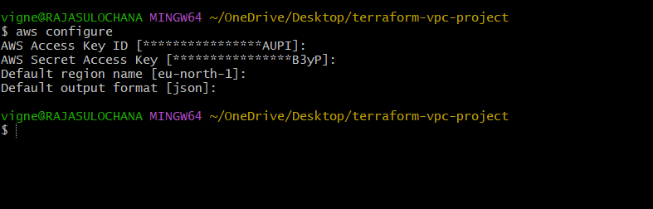

Step 1.4 — Create vpc.tf
Create file:
touch vpc.tf

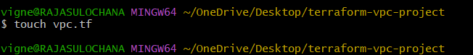

Open:
code vpc.tf

nano vpc.tf
Paste:
resource "aws_vpc" "main_vpc" {
cidr_block = "10.0.0.0/16"
enable_dns_support = true
enable_dns_hostnames = true
tags = {
Name = "custom-vpc"
}
}
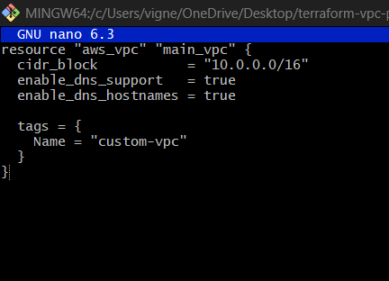

Explanation
resource
Used to create AWS resource.
resource

aws_vpc
AWS VPC resource type.
aws_vpc

main_vpc
Terraform local resource name.
"main_vpc"
Terraform internally refers as:
aws_vpc.main_vpc

cidr_block
Defines IP range.
10.0.0.0/16
Meaning:
- Total IPs ≈ 65,536

CIDR Visualization
$$10.0.0.0/16$$

enable_dns_support
Allows DNS resolution inside VPC.
true

enable_dns_hostnames
Allows EC2 public DNS names.
true

tags
Used for naming resources in AWS Console.
Name = "custom-vpc"

Step 1.5 — Initialize Terraform
Run:
terraform init
What happens:
- Downloads AWS provider
- Creates .terraform folder
- Creates .terraform.lock.hcl

Expected output:
Terraform has been successfully initialized!
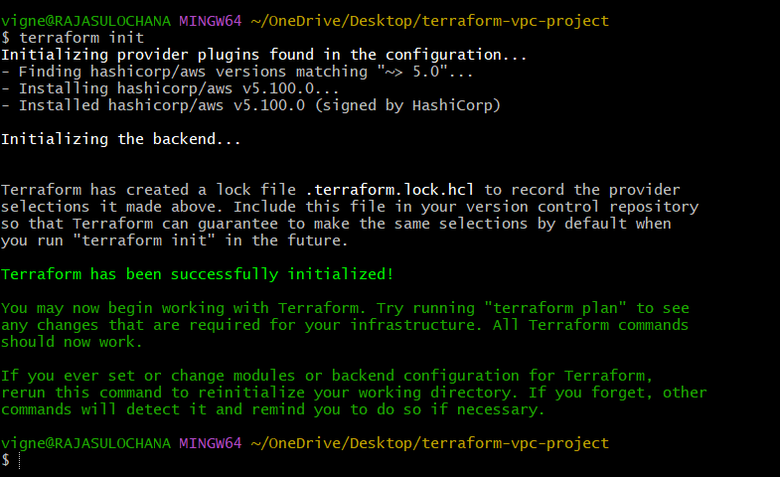

Step 1.6 — Validate Syntax
Run:
terraform validate
Expected:
Success! The configuration is valid.
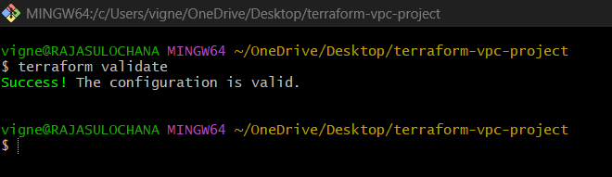

Step 1.7 — Check Execution Plan
Run:
terraform plan

Terraform shows:
- What resource will be created
- What changes will happen
Expected:
Plan: 1 to add, 0 to change, 0 to destroy.
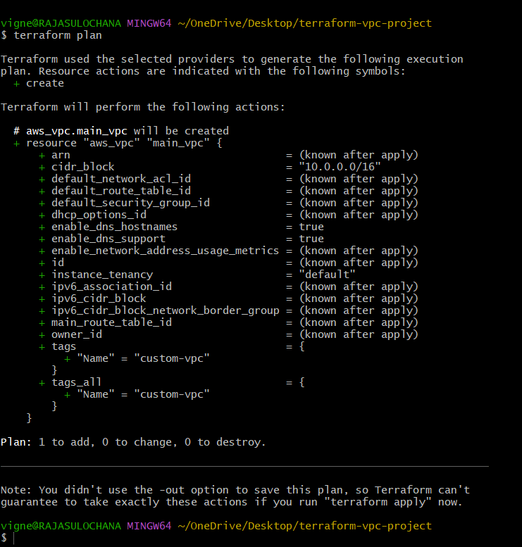

Step 1.8 — Create VPC
Run:
terraform apply

Terraform asks:
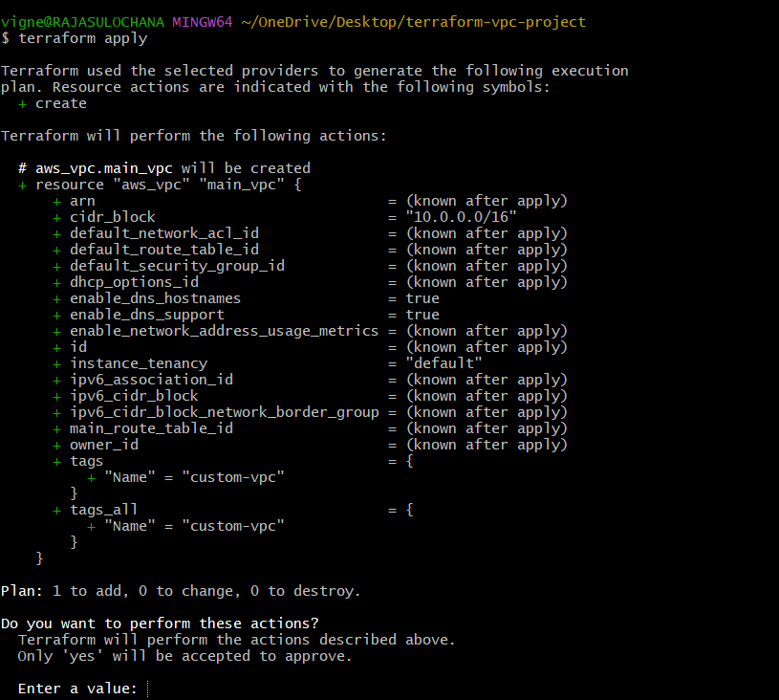

Do you want to perform these actions?
Type:
yes
Expected:
Apply complete! Resources: 1 added.
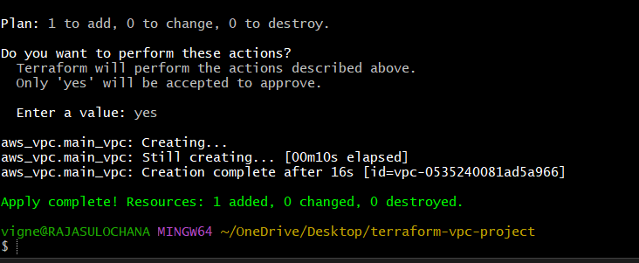

Step 1.9 — Verify in AWS Console
Go to:
AWS Console VPC Dashboard
Navigate:
VPC Dashboard → Your VPCs
You will see:
custom-vpc
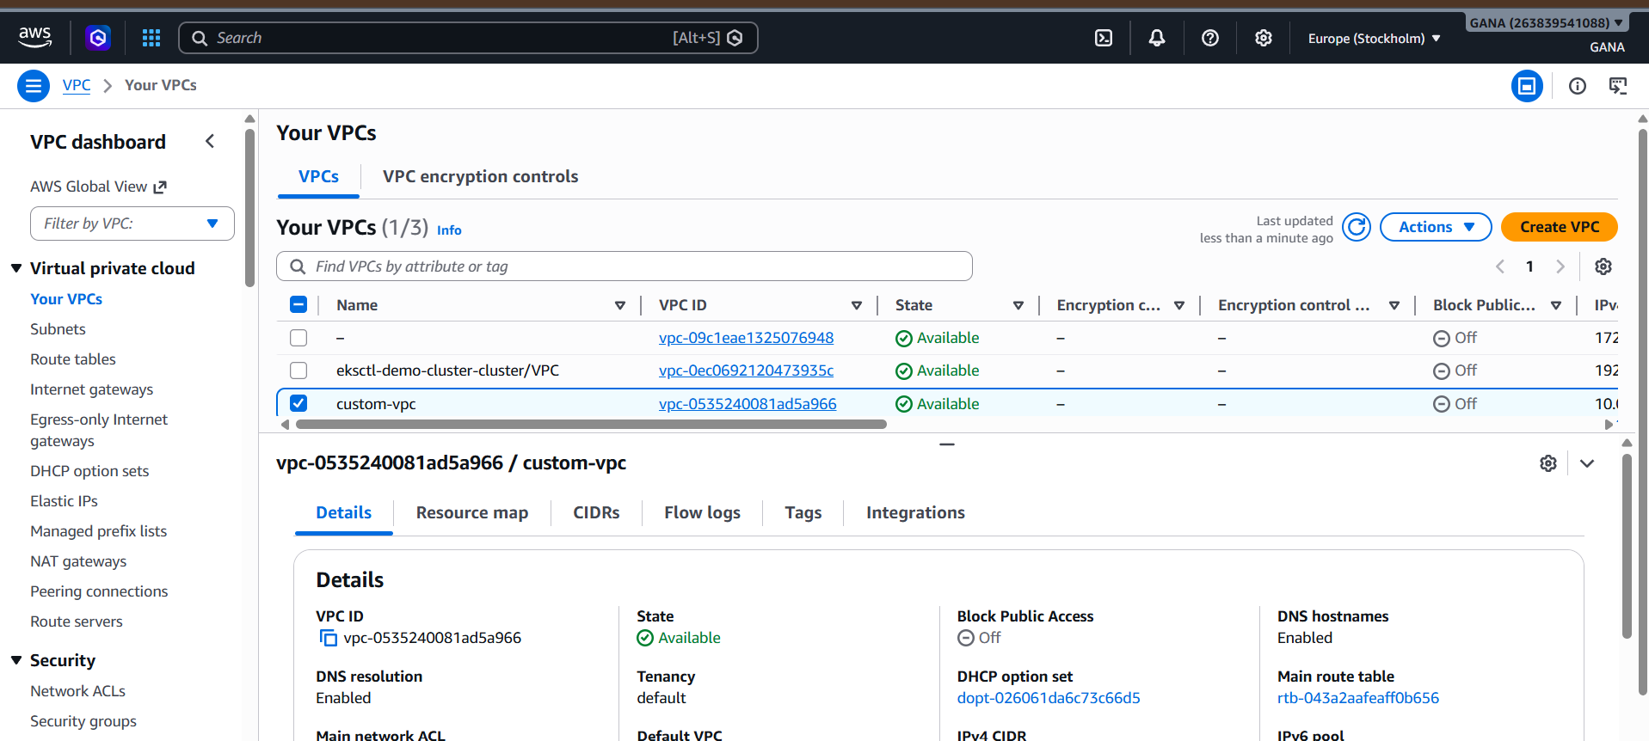

Project Structure
terraform-vpc-project/
│
├── provider.tf
├── vpc.tf
├── .terraform/
├── terraform.tfstate
└── .terraform.lock.hcl

Important Files
File | Purpose
provider.tf | AWS provider configuration
vpc.tf | VPC resource definition
terraform.tfstate | Tracks infrastructure
.terraform | Provider plugins

2) Create Internet gateway

Step 2 — Create Internet Gateway in Terraform
Now we will create:
- Internet Gateway
- Attach it to VPC
- Verify in AWS Console

What is Internet Gateway?
An Internet Gateway (IGW) allows resources inside the VPC to access the internet.
Without IGW:
- EC2 cannot access internet
- No package installation
- No website hosting
- No outbound/inbound internet traffic
Existing Files
Currently project contains:
terraform-vpc-project/
│
├── provider.tf
├── vpc.tf
Step 2.1 — Create igw.tf
Create file:
touch igw.tf
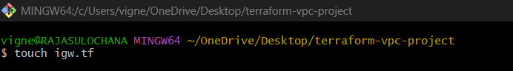
Open file:
code igw.tf
Paste below code:
nano igw.tf
resource "aws_internet_gateway" "main_igw" {
vpc_id = aws_vpc.main_vpc.id
tags = {
Name = "custom-igw"
}
}
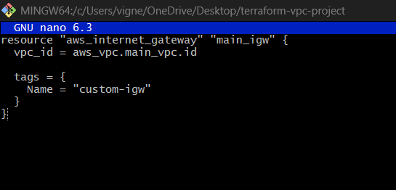

Explanation
resource
Used to create AWS resource.
resource

aws_internet_gateway
Terraform AWS Internet Gateway resource type.
aws_internet_gateway

main_igw
Terraform local name.
main_igw
Terraform internally refers as:
aws_internet_gateway.main_igw

vpc_id
Attaches Internet Gateway to VPC.
vpc_id = aws_vpc.main_vpc.id
Meaning:
- Take ID from previously created VPC
- Attach IGW to that VPC
Example:
vpc-08a1bcd234
tags
Used for naming resource in AWS console.
Name = "custom-igw"

Step 2.2 — Format Terraform Files
Run:
terraform fmt

Purpose:
- Formats Terraform code properly
- Aligns spacing automatically

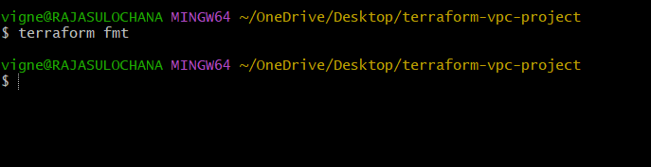
Step 2.3 — Initialize Again (Optional)
Usually not needed because provider already downloaded.
But safe to run:
terraform init
Expected:
Terraform has been successfully initialized!
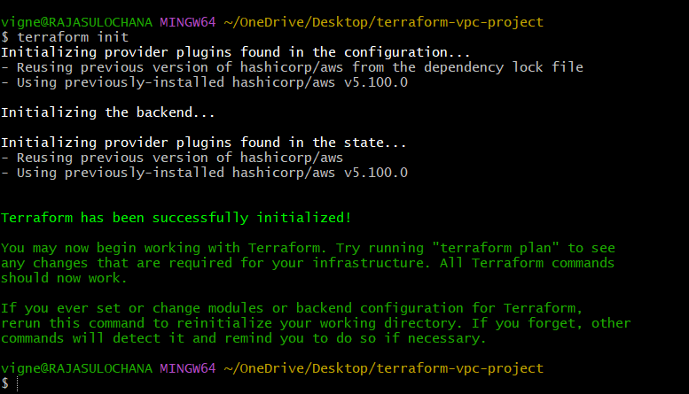

Step 2.4 — Validate Configuration
Run:
terraform validate
Expected:
Success! The configuration is valid.
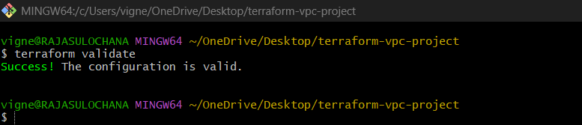

Step 2.5 — Check Terraform Plan
Run:
terraform plan
Expected:
Plan: 1 to add, 0 to change, 0 to destroy.
Terraform will show:
+ aws_internet_gateway.main_igw
Meaning:
- One new Internet Gateway will be created
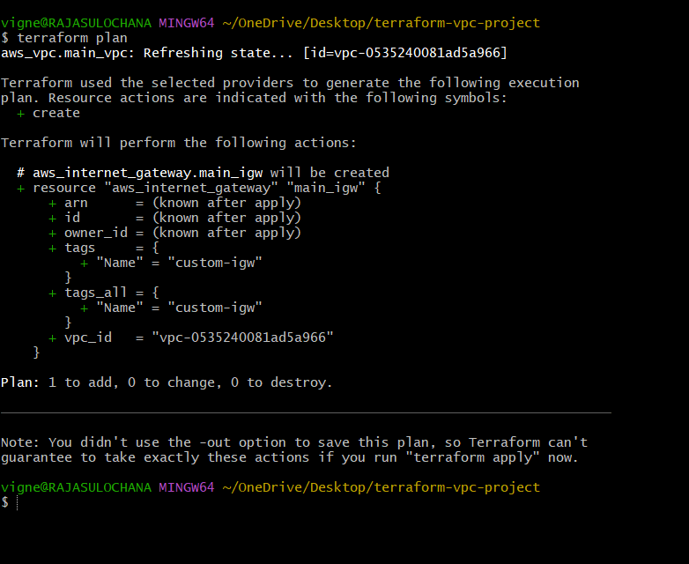

Step 2.6 — Apply Configuration
Run:
terraform apply
Terraform asks:
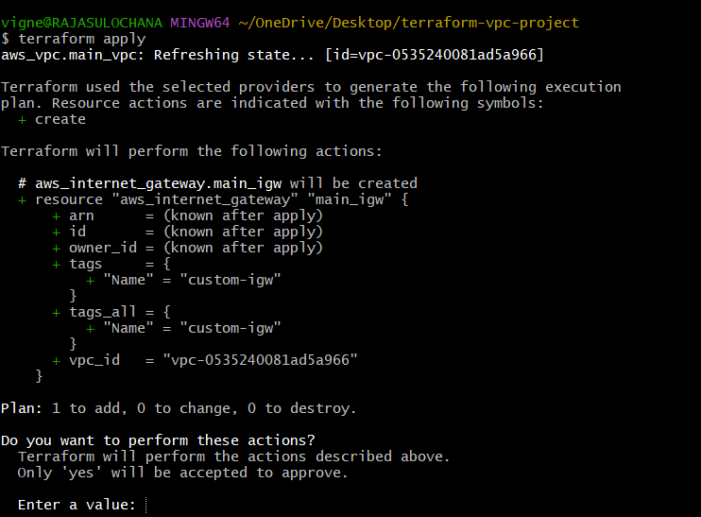
Do you want to perform these actions?
Type:
yes
Expected output:
Apply complete! Resources: 1 added.
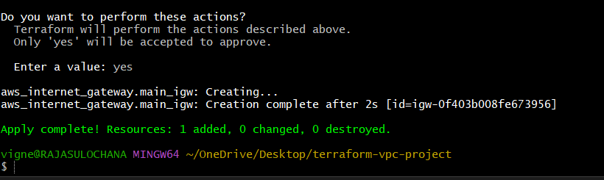

Step 2.7 — Verify in AWS Console
Open:
AWS VPC Internet Gateways Console
Navigate:
VPC Dashboard → Internet Gateways
You will see:
custom-igw
Status:
Attached
Attached VPC:
custom-vpc

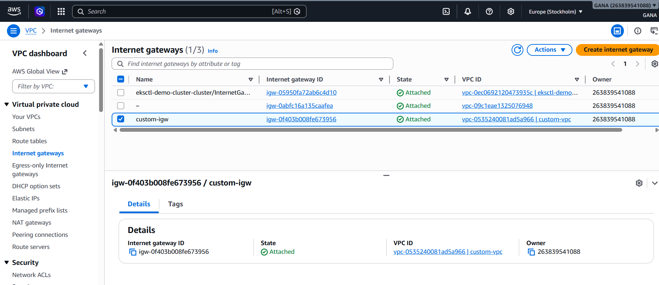

Updated Project Structure
terraform-vpc-project/
│
├── provider.tf
├── vpc.tf
├── igw.tf
├── terraform.tfstate
└── .terraform/

How Terraform Connects Resources
Terraform automatically understands dependency:
vpc_id = aws_vpc.main_vpc.id
So:
- Create VPC first
- Then attach Internet Gateway

3) Create Custom Route Table

Step 3 — Create Custom Route Table in Terraform
Now we will create:
- Custom Route Table
- Route to Internet Gateway
- Attach route for internet access

What is Route Table?
A Route Table controls network traffic inside the VPC.
It decides:
Where should traffic go?
Example:
Destination | Target
0.0.0.0/0 | Internet Gateway
Meaning:
Send all internet traffic to IGW
Current Infrastructure
Currently created:
VPC → Internet Gateway
Now adding:
Custom Route Table

Step 3.1 — Create route-table.tf
Create file:
touch route-table.tf
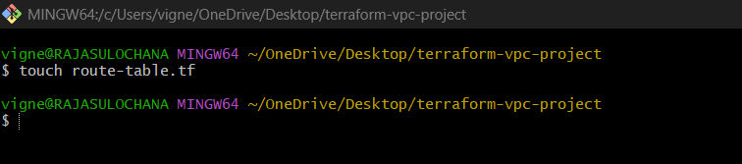
Open file:
code route-table.tf
Paste below code:
nano route-table.tf
resource "aws_route_table" "main_route_table" {
vpc_id = aws_vpc.main_vpc.id
route {
cidr_block = "0.0.0.0/0"
gateway_id = aws_internet_gateway.main_igw.id
}
tags = {
Name = "custom-route-table"
}
}
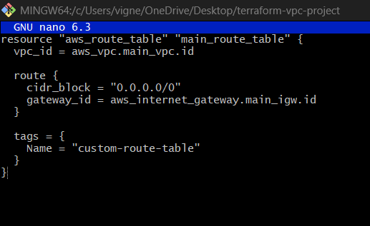

Explanation
resource
Used to create AWS resource.
resource

aws_route_table
Terraform AWS Route Table resource.
aws_route_table

main_route_table
Terraform local resource name.
main_route_table
Terraform internally refers as:
aws_route_table.main_route_table

vpc_id
Associates route table with VPC.
vpc_id = aws_vpc.main_vpc.id

Route Table Flow

Understanding route Block
route {
Defines routing rule.

cidr_block
cidr_block = "0.0.0.0/0"
Meaning:
- All IPv4 traffic
- Entire internet

CIDR Visualization
$$0.0.0.0/0$$

gateway_id
gateway_id = aws_internet_gateway.main_igw.id
Meaning:
Send internet traffic to Internet Gateway.
Terraform automatically gets:
igw-xxxxxxxx

tags
Used for naming in AWS Console.
Name = "custom-route-table"

Step 3.2 — Format Terraform Files
Run:
terraform fmt
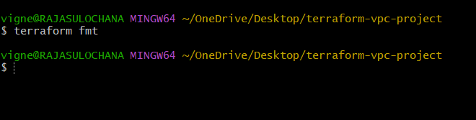

Step 3.3 — Validate Configuration
Run:
terraform validate
Expected:
Success! The configuration is valid.
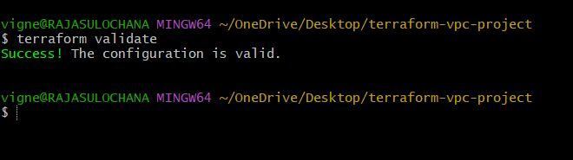

Step 3.4 — Check Terraform Plan
Run:
terraform plan
Expected:
Plan: 1 to add, 0 to change, 0 to destroy.
Terraform shows:
+ aws_route_table.main_route_table
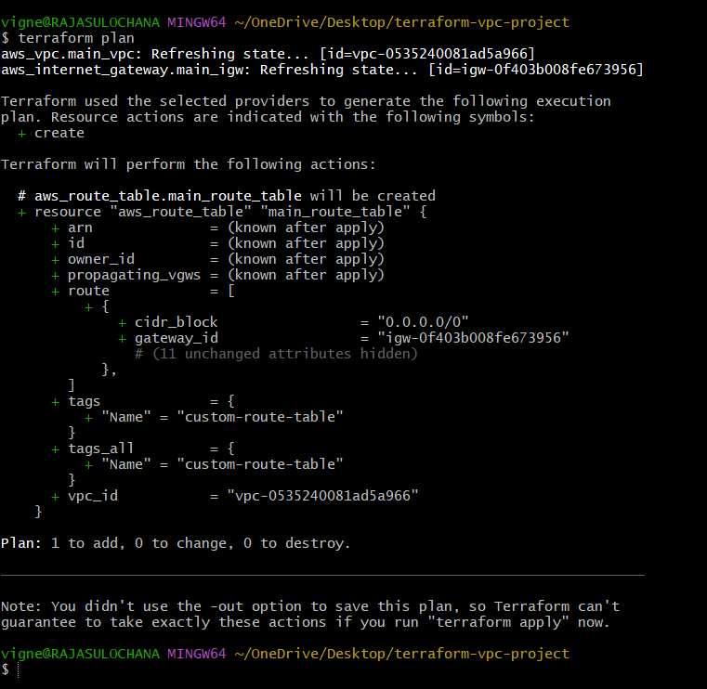

Step 3.5 — Apply Configuration
Run:
terraform apply
Terraform asks:
Do you want to perform these actions?
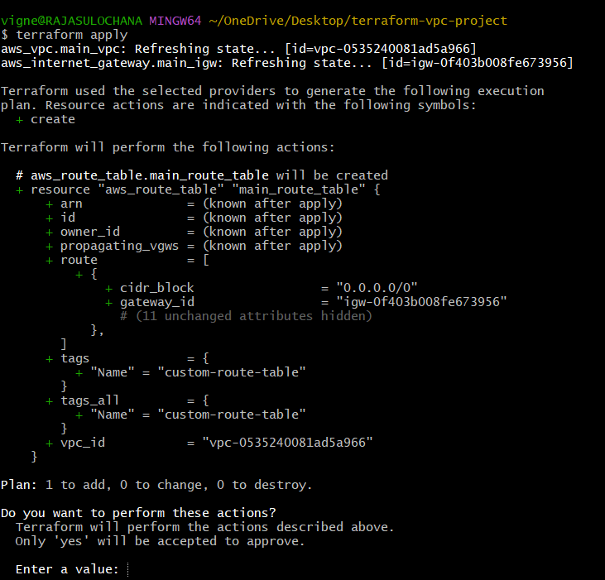
Type:
yes
Expected:
Apply complete! Resources: 1 added.
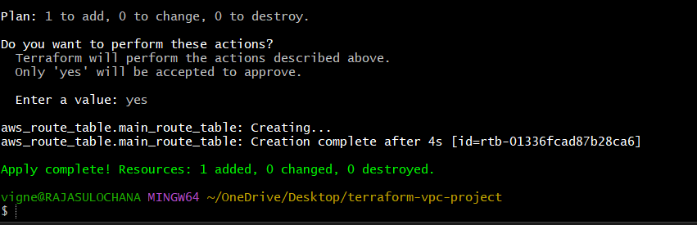

Step 3.6 — Verify in AWS Console
Open:
AWS Route Tables Console
Navigate:
VPC Dashboard → Route Tables
You will see:
custom-route-table
Inside Routes tab:
Destination | Target
10.0.0.0/16 | local
0.0.0.0/0 | igw-xxxx
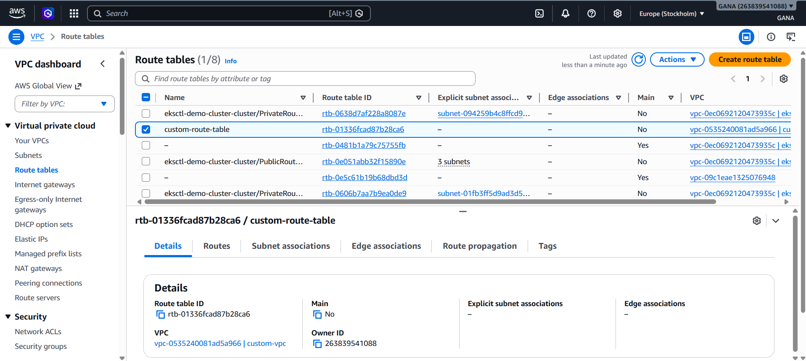

Why Route Table is Important
Without Route Table:
- Subnet cannot access internet
- EC2 cannot download packages
- Website inaccessible

Updated Project Structure
terraform-vpc-project/
│
├── provider.tf
├── vpc.tf
├── igw.tf
├── route-table.tf
├── terraform.tfstate
└── .terraform/

Infrastructure So Far
VPC
└── Internet Gateway
└── Route Table

Real-Time Networking Example
Suppose EC2 wants to access:
google.com
Flow:
EC2
→ Route Table
→ Internet Gateway
→ Internet

4) Create Subnet

Step 4 — Create Subnet in Terraform
Now we will create:
- Public Subnet
- CIDR block for subnet
- Availability Zone mapping
- Enable public IP assignment

What is a Subnet?
A Subnet is a smaller network inside a VPC.
VPC:
10.0.0.0/16
Subnet example:
10.0.1.0/24
Meaning:
- VPC = Big network
- Subnet = Small division inside VPC

Current Infrastructure
Currently created:
VPC
├── Internet Gateway
└── Route Table
Now adding:
Public Subnet

Step 4.1 — Create subnet.tf
Create file:
touch subnet.tf

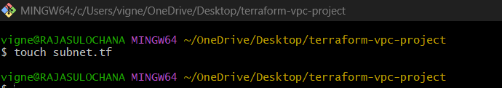
Open file:
code subnet.tf
Paste below code:
nano subnet.tf
resource "aws_subnet" "public_subnet" {
vpc_id = aws_vpc.main_vpc.id
cidr_block = "10.0.1.0/24"
availability_zone = "ap-south-1a"
map_public_ip_on_launch = true
tags = {
Name = "public-subnet"
}
}

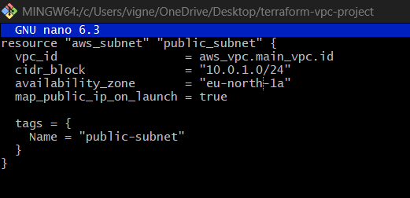

Explanation

resource
Used to create AWS resource.
resource

aws_subnet
Terraform AWS Subnet resource.
aws_subnet

public_subnet
Terraform local resource name.
public_subnet
Terraform internally refers as:
aws_subnet.public_subnet

vpc_id
Associates subnet with VPC.
vpc_id = aws_vpc.main_vpc.id
Meaning:
Subnet will be created inside:
custom-vpc

cidr_block
Defines subnet IP range.
cidr_block = "10.0.1.0/24"
Meaning:
- Subnet starts from:
10.0.1.0
- Total IPs ≈ 256

CIDR Visualization
$$10.0.1.0/24$$

VPC vs Subnet CIDR
Network | CIDR | Approx IPs
VPC | 10.0.0.0/16 | 65,536
Subnet | 10.0.1.0/24 | 256

availability_zone
availability_zone = "ap-south-1a"
Subnet will be created in:
Mumbai Availability Zone A

AWS Region & AZ
Region | Availability Zone
ap-south-1 | ap-south-1a
ap-south-1 | ap-south-1b

map_public_ip_on_launch
map_public_ip_on_launch = true
Meaning:
Every EC2 launched inside subnet gets:
Public IP automatically
Without this:
- EC2 gets only private IP
- No internet access

tags
Used for naming resource in AWS Console.
Name = "public-subnet"

Step 4.2 — Format Terraform Files
Run:
terraform fmt
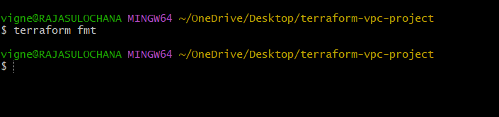

Step 4.3 — Validate Configuration
Run:
terraform validate
Expected:
Success! The configuration is valid.
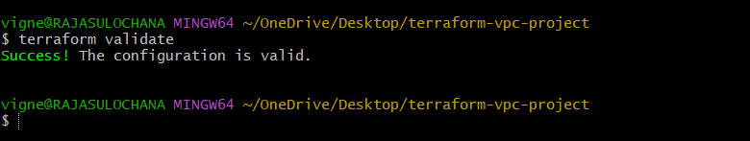

Step 4.4 — Check Terraform Plan
Run:
terraform plan
Expected:
Plan: 1 to add, 0 to change, 0 to destroy.
Terraform shows:
+ aws_subnet.public_subnet
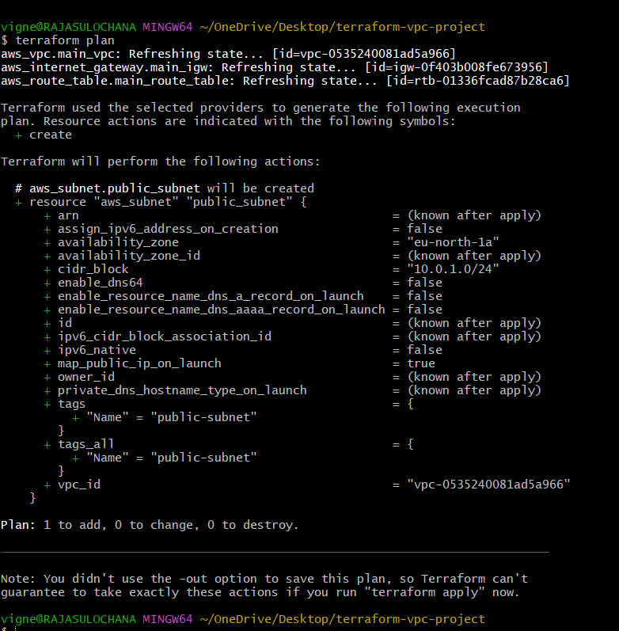

Step 4.5 — Apply Configuration
Run:
terraform apply
Terraform asks:
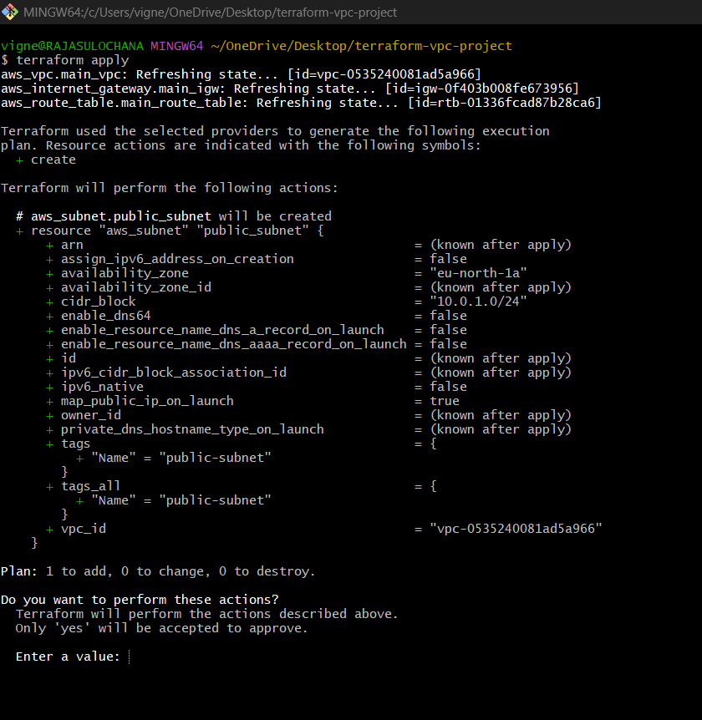

Do you want to perform these actions?
Type:
yes
Expected:
Apply complete! Resources: 1 added.
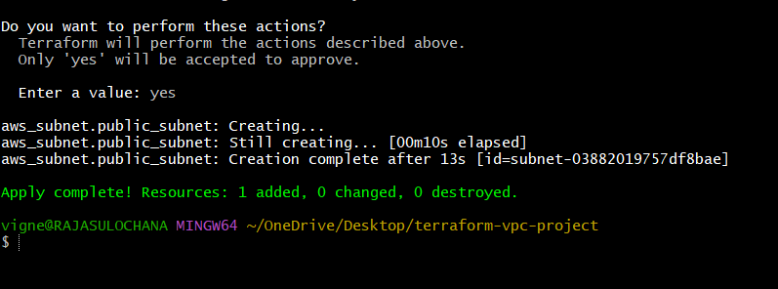

Step 4.6 — Verify in AWS Console
Open:
AWS Subnets Console
Navigate:
VPC Dashboard → Subnets
You will see:
public-subnet
Details:
Property | Value
CIDR | 10.0.1.0/24
AZ | ap-south-1a
VPC | custom-vpc

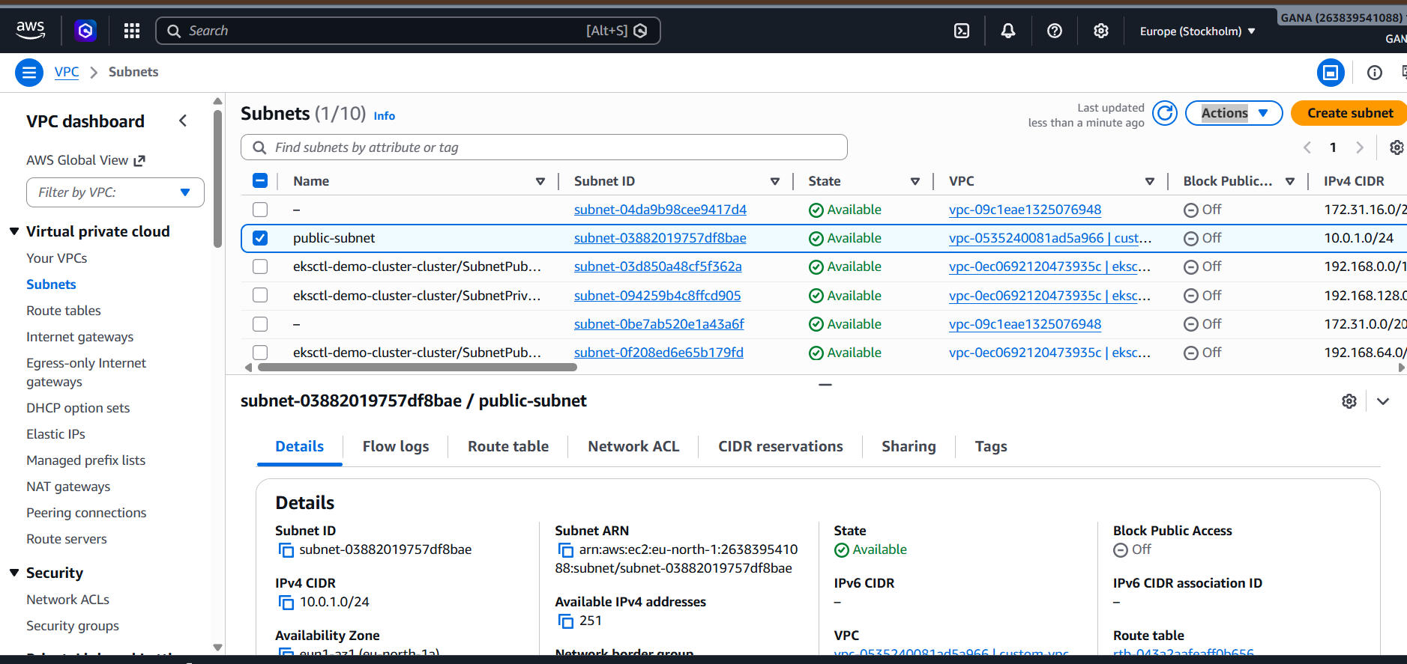

Updated Project Structure
terraform-vpc-project/
│
├── provider.tf
├── vpc.tf
├── igw.tf
├── route-table.tf
├── subnet.tf
├── terraform.tfstate
└── .terraform/

Infrastructure So Far
VPC
├── Internet Gateway
├── Route Table
└── Public Subnet

Real-Time Example
Suppose you launch:
- Ubuntu EC2
- Apache Server
- Nginx Website

They are launched inside subnet.
Subnet decides:
- Which IP range server gets
- Which AZ server runs in
- Whether server gets public IP

5) Associate subnet with Route Table

Step 5 — Associate Subnet with Route Table in Terraform
Now we will:
- Associate Public Subnet with Custom Route Table
- Enable internet routing for subnet
- Connect subnet traffic to Internet Gateway through Route Table

Why Route Table Association is Important?
Creating Route Table alone is NOT enough.
We must explicitly connect:
Subnet → Route Table
Otherwise:
- Subnet won't use internet route
- EC2 cannot access internet
- Apache website won't open

Current Infrastructure
Currently created:
VPC
├── Internet Gateway
├── Route Table
└── Public Subnet
Now connecting:
Public Subnet → Route Table

Step 5.1 — Create route-table-association.tf
Create file:
touch route-table-association.tf

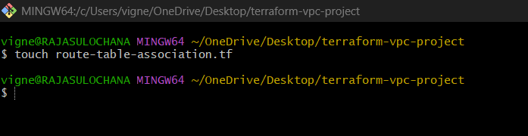
Open file:
code route-table-association.tf
Paste below code:
nano route-table-association.tf
resource "aws_route_table_association" "public_association" {
subnet_id = aws_subnet.public_subnet.id
route_table_id = aws_route_table.main_route_table.id
}

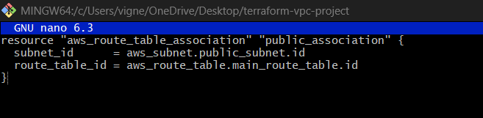

Explanation

resource
Used to create AWS resource.
resource

aws_route_table_association
Terraform resource used to connect:
Subnet ↔ Route Table

public_association
Terraform local resource name.
public_association
Terraform internally refers as:
aws_route_table_association.public_association

subnet_id
subnet_id = aws_subnet.public_subnet.id
Meaning:
Take subnet ID from:
public-subnet
Example:
subnet-0ab12345

route_table_id
route_table_id = aws_route_table.main_route_table.id
Meaning:
Attach subnet to:
custom-route-table
Example:
rtb-0ab12345

Complete Networking Flow
After association:
EC2
→ Subnet
→ Route Table
→ Internet Gateway
→ Internet

Step 5.2 — Format Terraform Files
Run:
terraform fmt
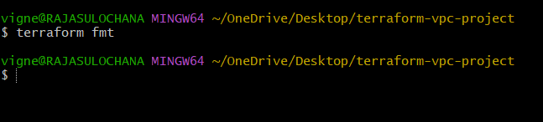

Step 5.3 — Validate Configuration
Run:
terraform validate
Expected:
Success! The configuration is valid.
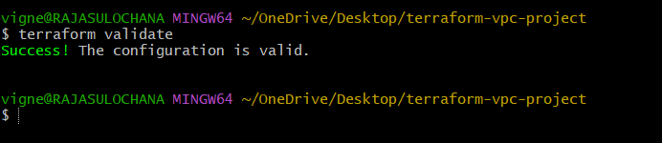

Step 5.4 — Check Terraform Plan
Run:
terraform plan
Expected:
Plan: 1 to add, 0 to change, 0 to destroy.
Terraform shows:
+ aws_route_table_association.public_association
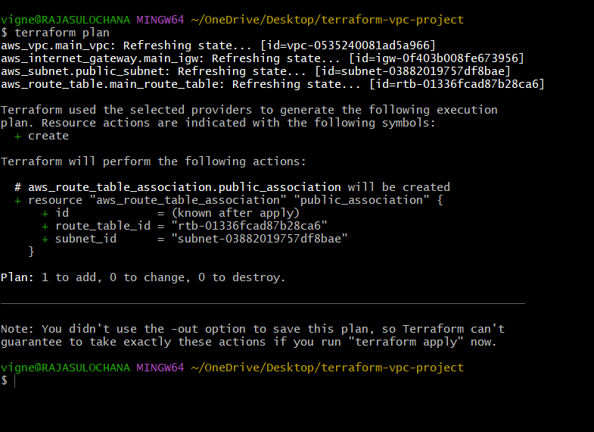

Step 5.5 — Apply Configuration
Run:
terraform apply
Terraform asks:
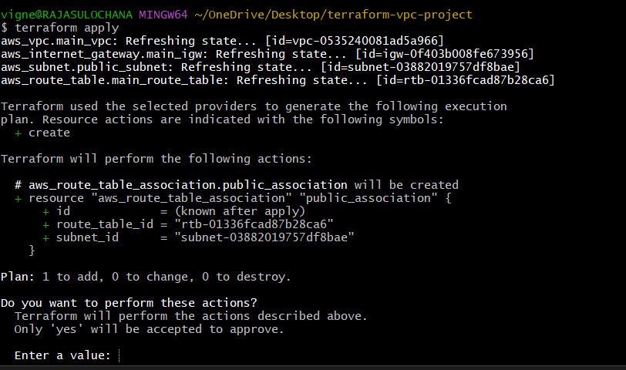
Do you want to perform these actions?
Type:
yes
Expected:
Apply complete! Resources: 1 added.
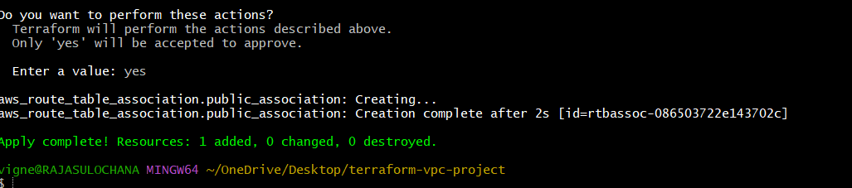

Step 5.6 — Verify in AWS Console
Open:
AWS Route Tables Console
Navigate:
VPC Dashboard → Route Tables
Select:
custom-route-table
Open:
Subnet Associations tab
You will see:
public-subnet
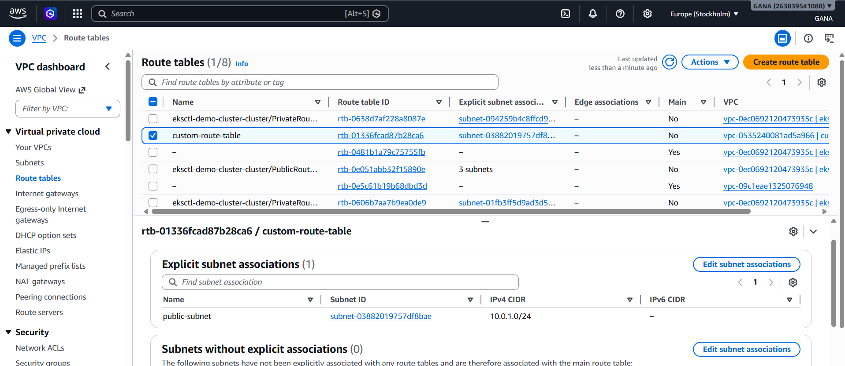

Updated Project Structure
terraform-vpc-project/
│
├── provider.tf
├── vpc.tf
├── igw.tf
├── route-table.tf
├── subnet.tf
├── route-table-association.tf
├── terraform.tfstate
└── .terraform/

Infrastructure So Far
VPC
├── Internet Gateway
├── Route Table
│ └── Associated with Public Subnet
└── Public Subnet

Real-Time Networking Scenario
Suppose EC2 inside subnet tries:
sudo apt update
Traffic flow:
EC2
→ Subnet
→ Route Table
→ Internet Gateway
→ Ubuntu Repository Servers
Without association:
Internet access fails

6) Create Security Group to allow port 22.80,443

Step 6 — Create Security Group to Allow Ports 22, 80, 443 in Terraform
Now we will create:
- Security Group
- Allow SSH (22)
- Allow HTTP (80)
- Allow HTTPS (443)
- Allow outbound internet traffic

What is Security Group?
A Security Group acts like a virtual firewall for EC2 instances.
It controls:
- Inbound traffic
- Outbound traffic
Example:
Port | Purpose
22 | SSH Login
80 | HTTP Website
443 | HTTPS Secure Website

Current Infrastructure
Currently created:
VPC
├── Internet Gateway
├── Route Table
└── Public Subnet
Now adding:
Security Group

Step 6.1 — Create security-group.tf
Create file:
touch security-group.tf
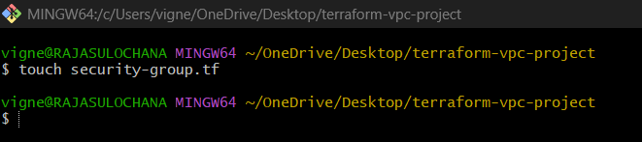
Open file:
code security-group.tf
Paste below code:
nano security-group.tf
resource "aws_security_group" "web_sg" {
name = "web-security-group"
description = "Allow SSH HTTP HTTPS"
vpc_id = aws_vpc.main_vpc.id
ingress {
description = "SSH Access"
from_port = 22
to_port = 22
protocol = "tcp"
cidr_blocks = ["0.0.0.0/0"]
}
ingress {
description = "HTTP Access"
from_port = 80
to_port = 80
protocol = "tcp"
cidr_blocks = ["0.0.0.0/0"]
}
ingress {
description = "HTTPS Access"
from_port = 443
to_port = 443
protocol = "tcp"
cidr_blocks = ["0.0.0.0/0"]
}
egress {
from_port = 0
to_port = 0
protocol = "-1"
cidr_blocks = ["0.0.0.0/0"]
}
tags = {
Name = "web-security-group"
}
}

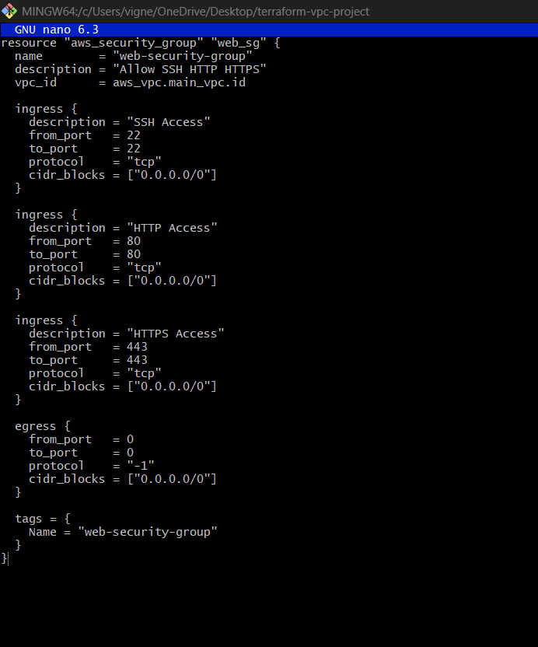

Explanation
resource
Used to create AWS resource.
resource

aws_security_group
Terraform AWS Security Group resource.
aws_security_group

web_sg
Terraform local resource name.
web_sg
Terraform internally refers as:
aws_security_group.web_sg

name
Security Group name in AWS Console.
web-security-group

description
Purpose of security group.
Allow SSH HTTP HTTPS

vpc_id
Associates Security Group with VPC.
vpc_id = aws_vpc.main_vpc.id

Understanding ingress Rules
ingress
Means:
Incoming traffic

Port 22 — SSH
from_port = 22
to_port = 22
Purpose:
Remote login to EC2 server.
Protocol:
tcp

SSH Visualization
$$22→SSH$$

Port 80 — HTTP
from_port = 80
to_port = 80
Purpose:
Website traffic.

HTTP Visualization
$$80→HTTP$$

Port 443 — HTTPS
from_port = 443
to_port = 443
Purpose:
Secure encrypted website traffic.

HTTPS Visualization
$$443→HTTPS$$

cidr_blocks
cidr_blocks = ["0.0.0.0/0"]
Meaning:
Allow access from:
Anywhere on internet

CIDR Meaning
$$0.0.0.0/0$$

Understanding egress Rule
egress
Means:
Outgoing traffic

protocol = "-1"
protocol = "-1"
Meaning:
Allow all protocols.

from_port = 0 to_port = 0
Means:
All ports allowed outbound.

Step 6.2 — Format Terraform Files
Run:
terraform fmt
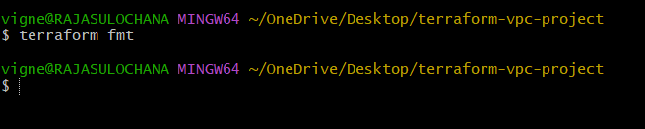

Step 6.3 — Validate Configuration
Run:
terraform validate
Expected:
Success! The configuration is valid.
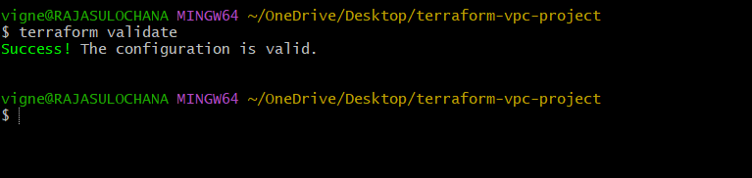

Step 6.4 — Check Terraform Plan
Run:
terraform plan
Expected:
Plan: 1 to add, 0 to change, 0 to destroy.
Terraform shows:
+ aws_security_group.web_sg
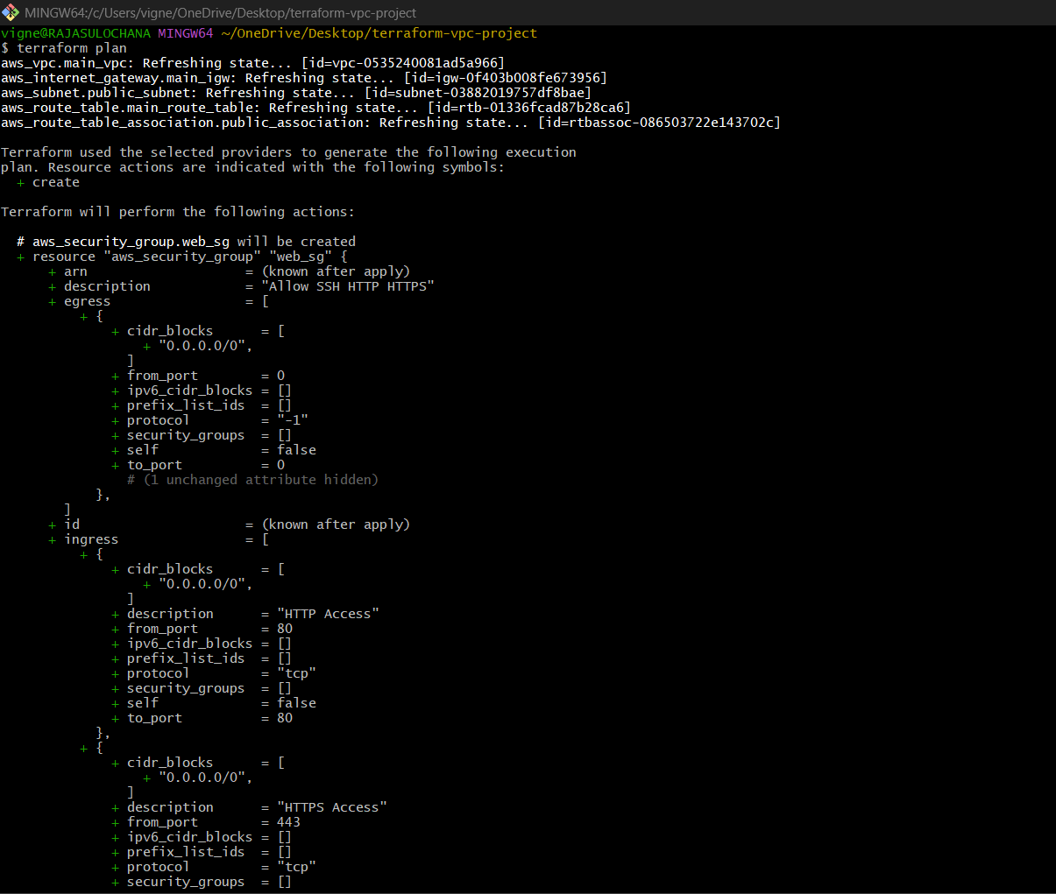
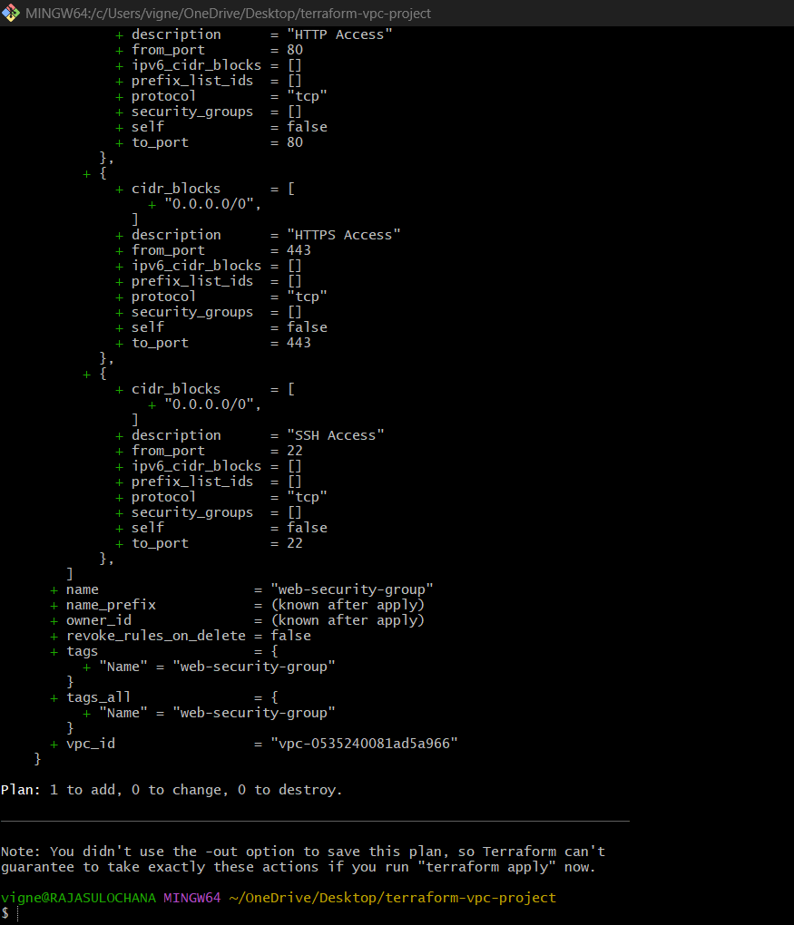

Step 6.5 — Apply Configuration
Run:
terraform apply
Terraform asks:
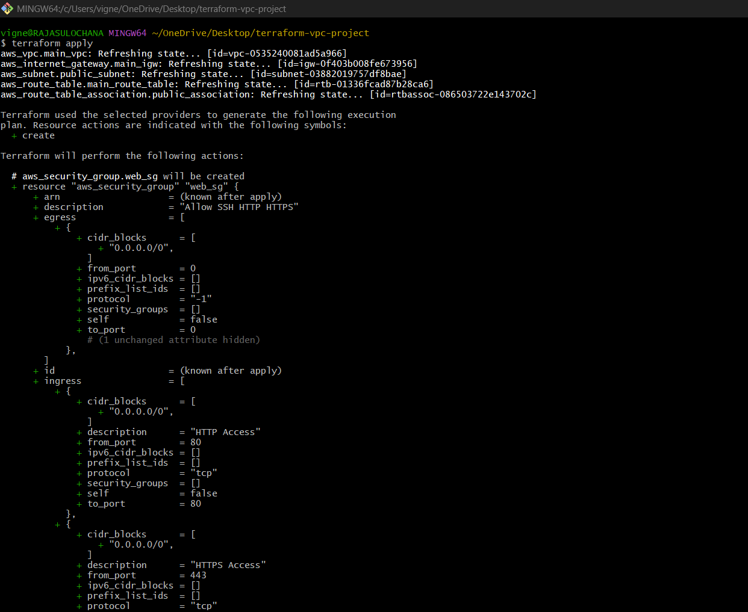
Do you want to perform these actions?
Type:
yes
Expected:
Apply complete! Resources: 1 added.
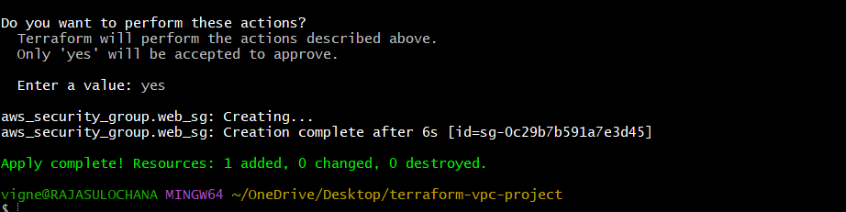

Step 6.6 — Verify in AWS Console
Open:
AWS Security Groups Console
Navigate:
EC2 Dashboard → Security Groups
You will see:
web-security-group
Inbound Rules:
Type | Port
SSH | 22
HTTP | 80
HTTPS | 443

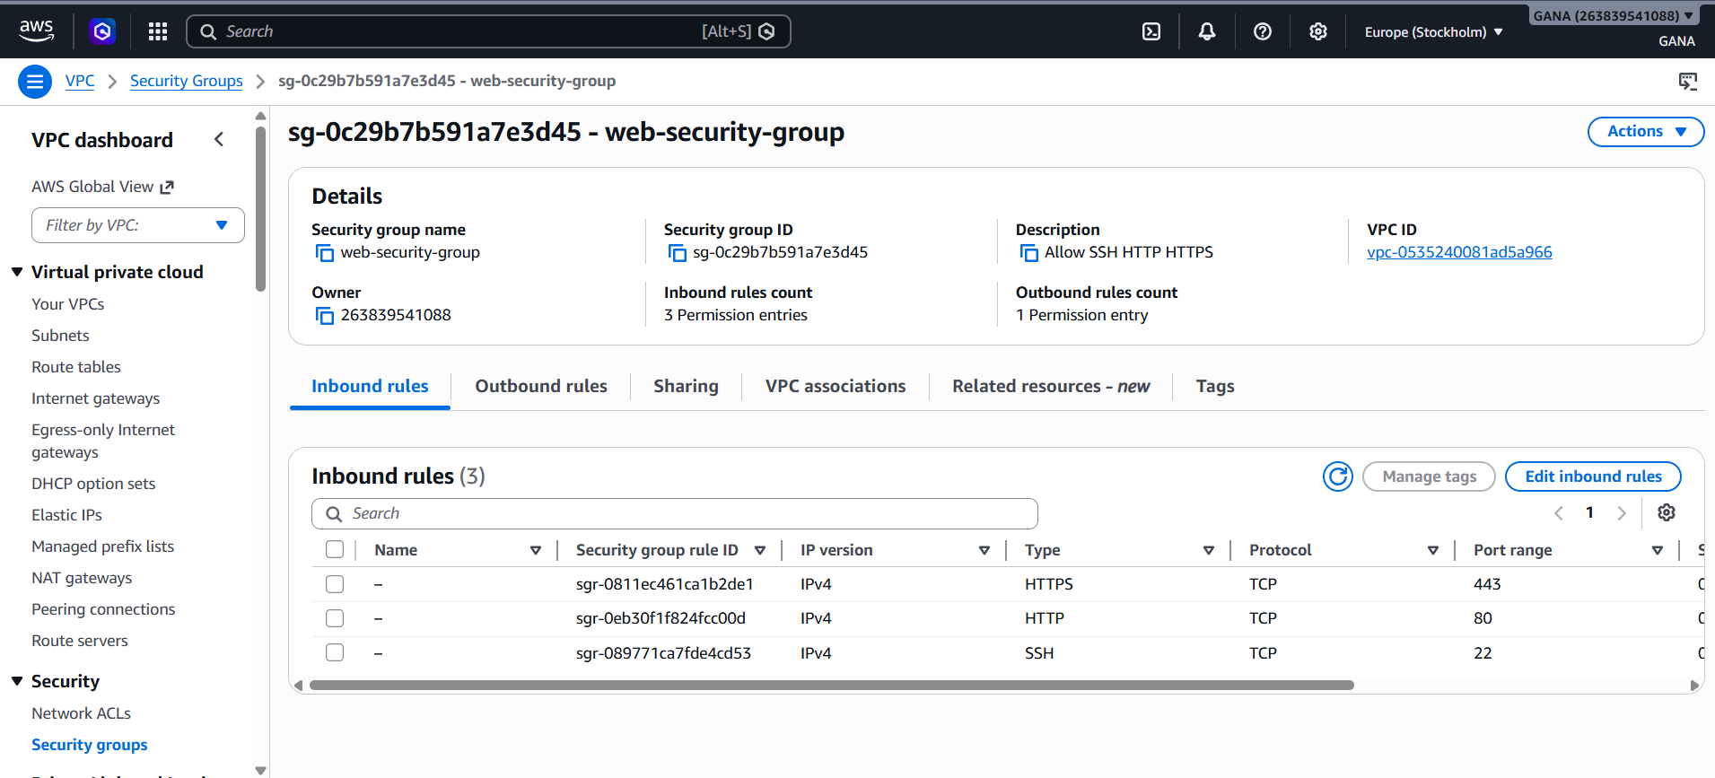
Updated Project Structure
terraform-vpc-project/
│
├── provider.tf
├── vpc.tf
├── igw.tf
├── route-table.tf
├── subnet.tf
├── route-table-association.tf
├── security-group.tf
├── terraform.tfstate
└── .terraform/

Infrastructure So Far
VPC
├── Internet Gateway
├── Route Table
├── Public Subnet
└── Security Group

7) Create a network interface with an ip in the subnet that was created in step 4

Step 7 — Create Network Interface with Private IP in Terraform
Now we will create:
- Elastic Network Interface (ENI)
- Attach it to Public Subnet
- Assign private IP
- Attach Security Group

What is Network Interface?
A Network Interface (ENI) is a virtual network card for AWS EC2 instances.
It contains:
- Private IP
- Public IP (optional)
- MAC Address
- Security Groups
Think of it like:
Virtual LAN card

Current Infrastructure
Currently created:
VPC
├── Internet Gateway
├── Route Table
├── Public Subnet
└── Security Group
Now adding:
Elastic Network Interface (ENI)

Step 7.1 — Create network-interface.tf
Create file:
touch network-interface.tf
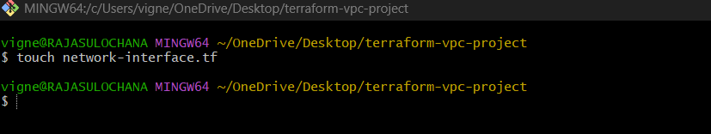
Open file:
code network-interface.tf
Paste below code:
nano network-interface.tf

resource "aws_network_interface" "web_server_nic" {
subnet_id = aws_subnet.public_subnet.id
private_ips = ["10.0.1.50"]
security_groups = [aws_security_group.web_sg.id]
tags = {
Name = "web-server-nic"
}
}
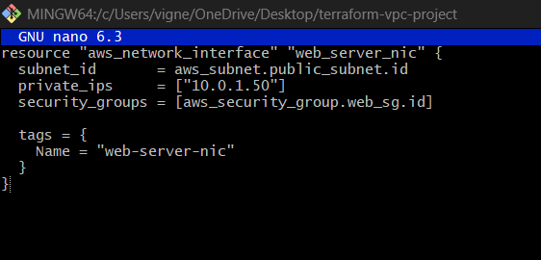

Explanation
resource
Used to create AWS resource.
resource

aws_network_interface
Terraform AWS ENI resource.
aws_network_interface

web_server_nic
Terraform local resource name.
web_server_nic
Terraform internally refers as:
aws_network_interface.web_server_nic
subnet_id
subnet_id = aws_subnet.public_subnet.id
Meaning:
Attach ENI to:
public-subnet
Terraform automatically gets:
subnet-xxxxxxxx

private_ips
private_ips = ["10.0.1.50"]
Assigns private IP to ENI.
Meaning:
10.0.1.50
belongs inside subnet CIDR:
10.0.1.0/24

Private IP Visualization
$$10.0.1.50∈10.0.1.0/24$$

Why Choose 10.0.1.50?
Because:
- It belongs to subnet range
- Easy to identify manually
- Common server practice

security_groups
security_groups = [aws_security_group.web_sg.id]
Attaches Security Group to ENI.
Meaning:
ENI follows rules:
- SSH allowed
- HTTP allowed
- HTTPS allowed

Security Flow
Internet
→ Security Group
→ Network Interface
→ EC2

tags
Used for naming resource in AWS Console.
Name = "web-server-nic"

Step 7.2 — Format Terraform Files
Run:
terraform fmt
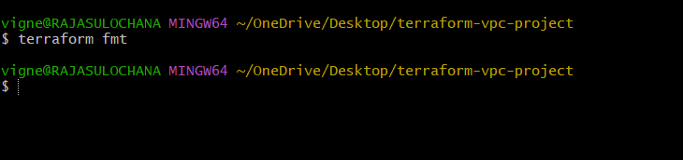

Step 7.3 — Validate Configuration
Run:
terraform validate
Expected:
Success! The configuration is valid.
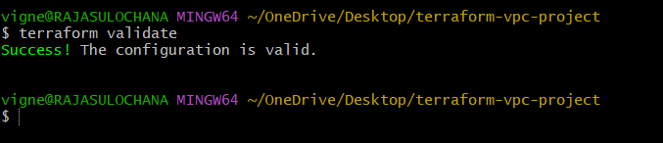

Step 7.4 — Check Terraform Plan
Run:
terraform plan
Expected:
Plan: 1 to add, 0 to change, 0 to destroy.
Terraform shows:
+ aws_network_interface.web_server_nic
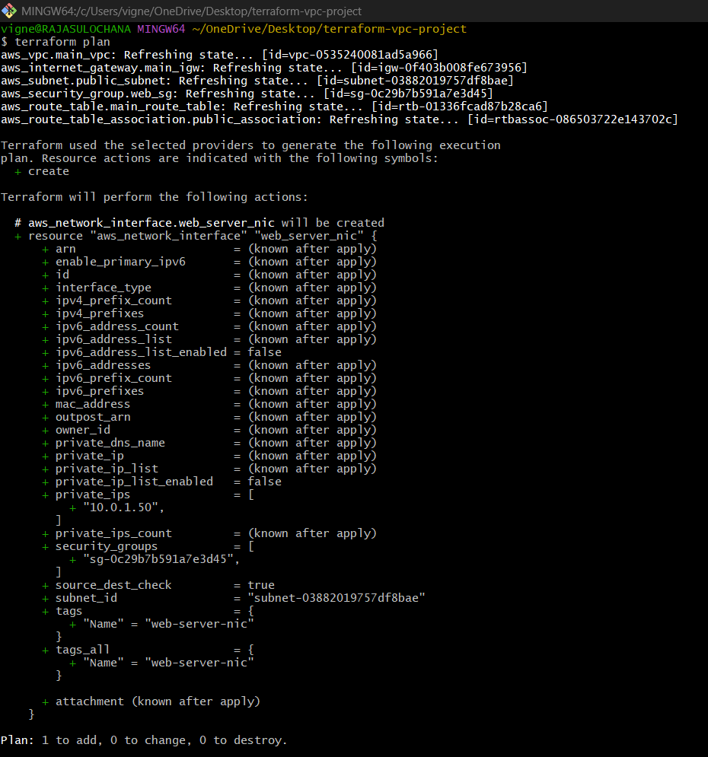

Step 7.5 — Apply Configuration
Run:
terraform apply
Terraform asks:
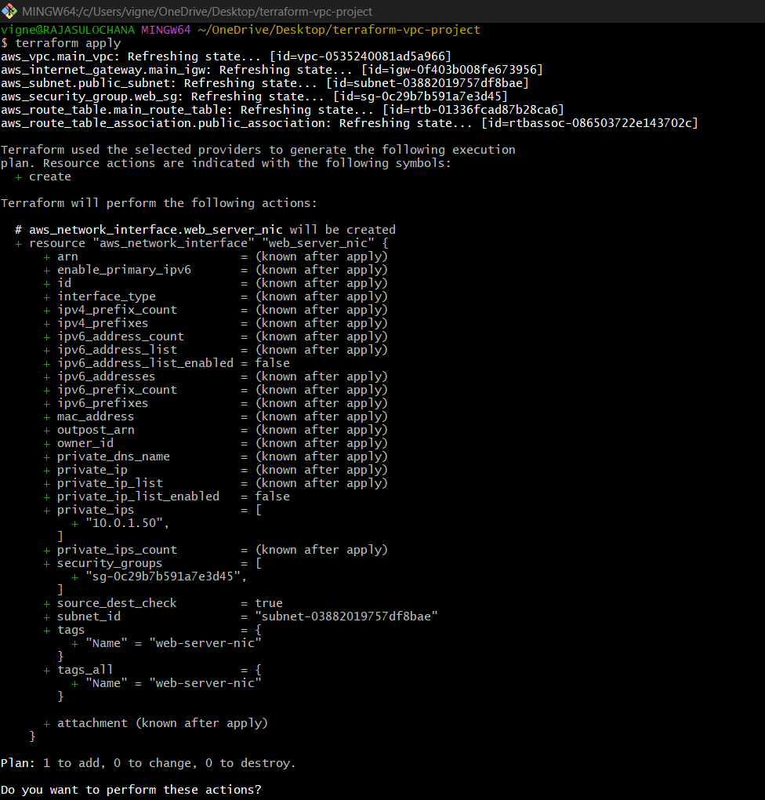

Do you want to perform these actions?
Type:
yes
Expected:
Apply complete! Resources: 1 added.
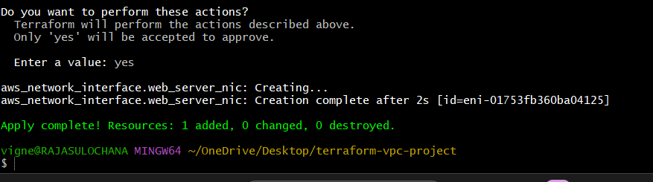

Step 7.6 — Verify in AWS Console
Open:
AWS Network Interfaces Console
Navigate:
EC2 Dashboard → Network Interfaces
You will see:
web-server-nic
Details:
Property | Value
Private IP | 10.0.1.50
Subnet | public-subnet
Security Group | web-security-group
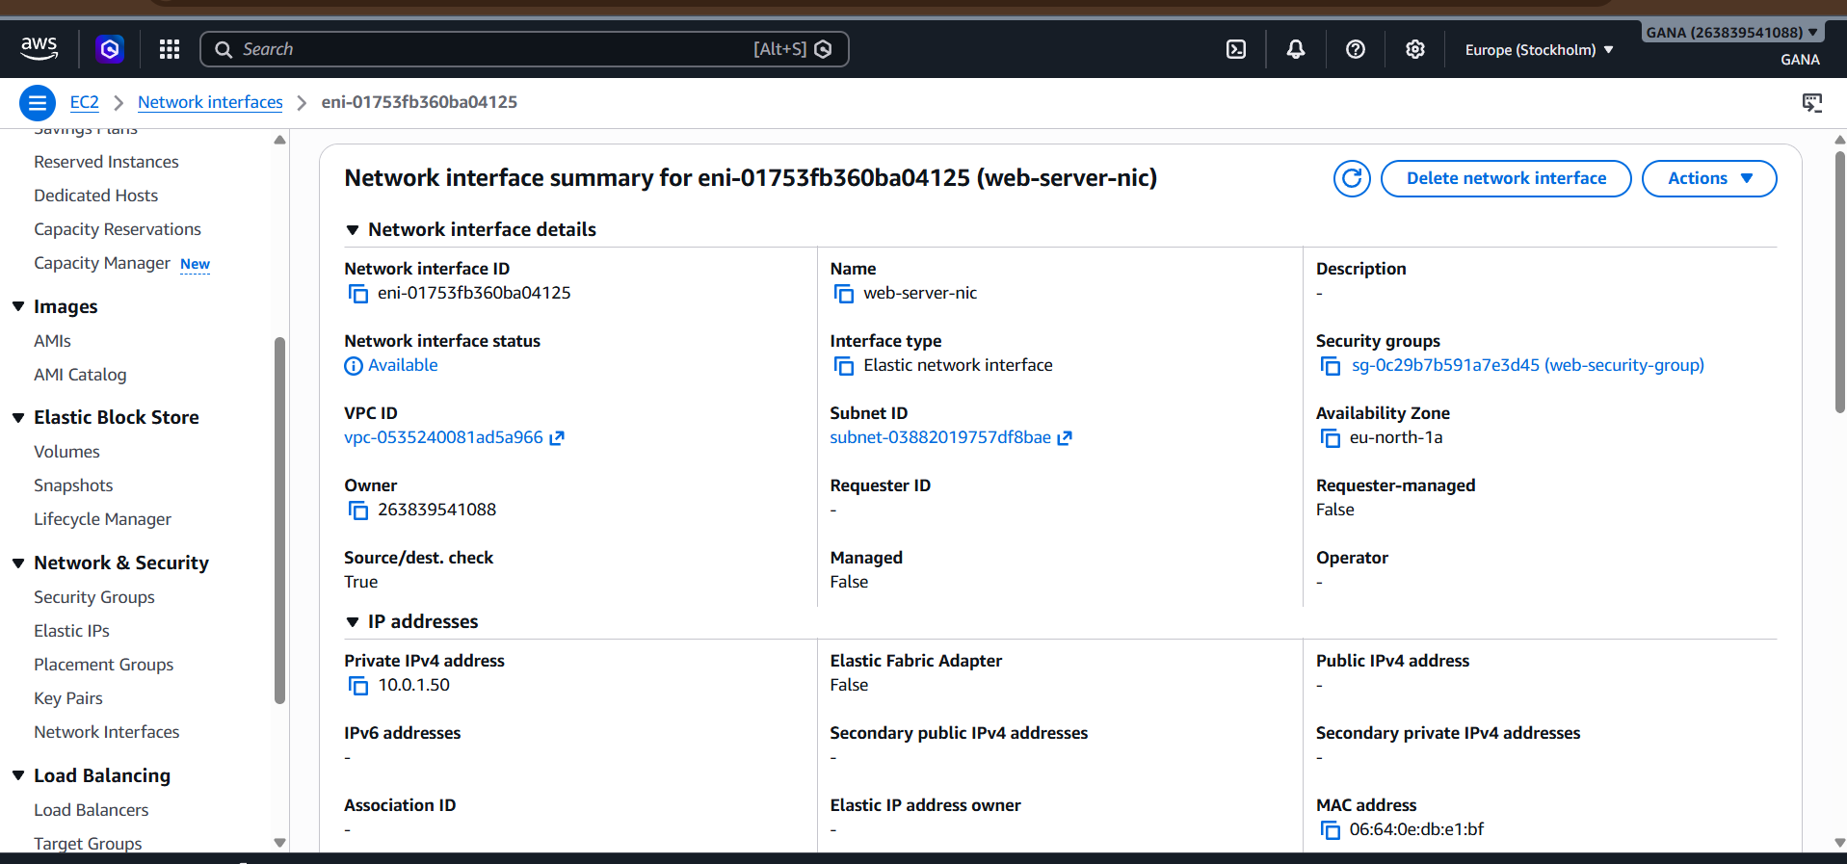

Updated Project Structure
terraform-vpc-project/
│
├── provider.tf
├── vpc.tf
├── igw.tf
├── route-table.tf
├── subnet.tf
├── route-table-association.tf
├── security-group.tf
├── network-interface.tf
├── terraform.tfstate
└── .terraform/

Infrastructure So Far
VPC
├── Internet Gateway
├── Route Table
├── Public Subnet
├── Security Group
└── Network Interface

Real-Time Example
Suppose EC2 server needs:
- Static private IP
- Dedicated network interface
- Multiple interfaces
Then ENI is used.
Example:
Server | ENI
Web Server | ENI-1
Database Server | ENI-2

8) Assign an elastic IP to the network interface created in step 7

Step 8 — Assign Elastic IP to Network Interface in Terraform
Now we will create:
- Elastic IP (EIP)
- Attach EIP to Network Interface
- Bind EIP with private IP

What is Elastic IP?
An Elastic IP is a static public IP address provided by AWS.
Normally EC2 public IP changes after restart.
Elastic IP gives:
✅ Permanent Public IP
Used for:
- Websites
- SSH access
- APIs
- Production servers

Current Infrastructure
Currently created:
VPC
├── Internet Gateway
├── Route Table
├── Public Subnet
├── Security Group
└── Network Interface
Now adding:
Elastic IP

Step 8.1 — Create elastic-ip.tf
Create file:
touch elastic-ip.tf

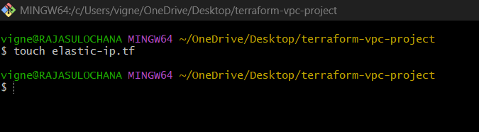
Open file:
code elastic-ip.tf
Paste below code:
nano elastic-ip.tf
resource "aws_eip" "web_eip" {
domain = "vpc"
network_interface = aws_network_interface.web_server_nic.id
associate_with_private_ip = "10.0.1.50"
tags = {
Name = "web-server-eip"
}
depends_on = [
aws_internet_gateway.main_igw
]
}

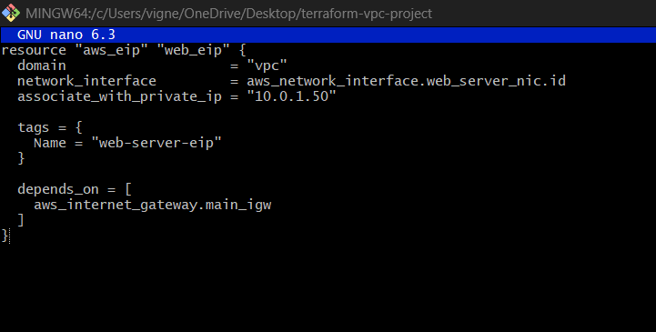

Explanation

resource
Used to create AWS resource.
resource

aws_eip
Terraform AWS Elastic IP resource.
aws_eip

web_eip
Terraform local resource name.
web_eip
Terraform internally refers as:
aws_eip.web_eip

domain = "vpc"
domain = "vpc"

Meaning:
Create EIP for VPC environment.

network_interface
network_interface = aws_network_interface.web_server_nic.id
Attach Elastic IP to:
web-server-nic
Terraform automatically gets:
eni-xxxxxxxx

associate_with_private_ip
associate_with_private_ip = "10.0.1.50"
Bind public IP with:
10.0.1.50

Public ↔ Private IP Mapping
Example:
Public IP | Private IP
13.x.x.x | 10.0.1.50

IP Mapping Visualization
$$Public IP→10.0.1.50$$

tags
Used for naming resource in AWS Console.
Name = "web-server-eip"

Understanding depends_on
depends_on = [
aws_internet_gateway.main_igw
]
Meaning:
Create Internet Gateway first.
Why?
Because Elastic IP requires internet routing readiness.

Dependency Flow
Internet Gateway
↓
Elastic IP
↓
Network Interface
Step 8.2 — Format Terraform Files
Run:
terraform fmt
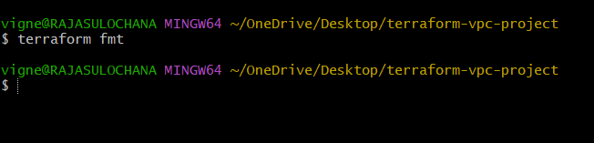

Step 8.3 — Validate Configuration
Run:
terraform validate
Expected:
Success! The configuration is valid.
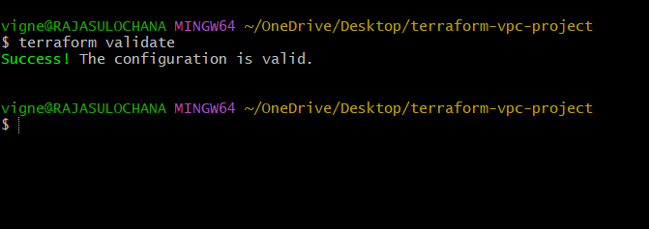

Step 8.4 — Check Terraform Plan
Run:
terraform plan
Expected:
Plan: 1 to add, 0 to change, 0 to destroy.
Terraform shows:
+ aws_eip.web_eip
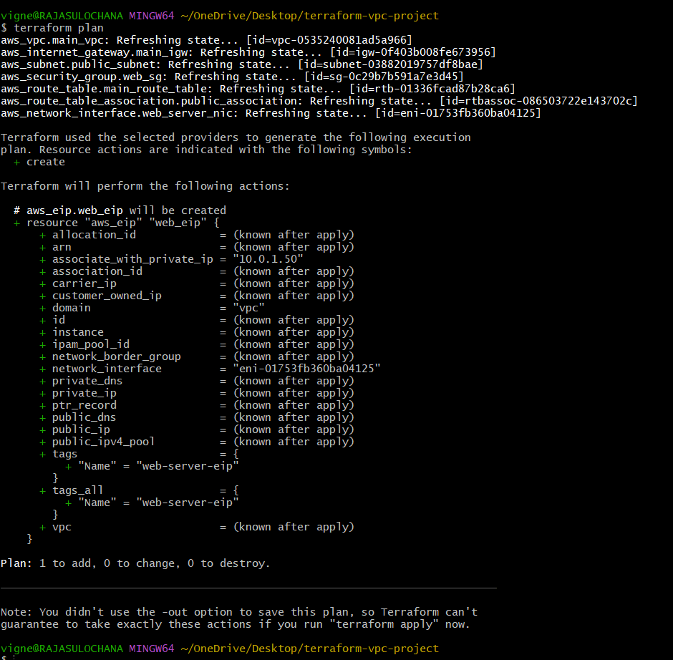

Step 8.5 — Apply Configuration
Run:
terraform apply
Terraform asks:
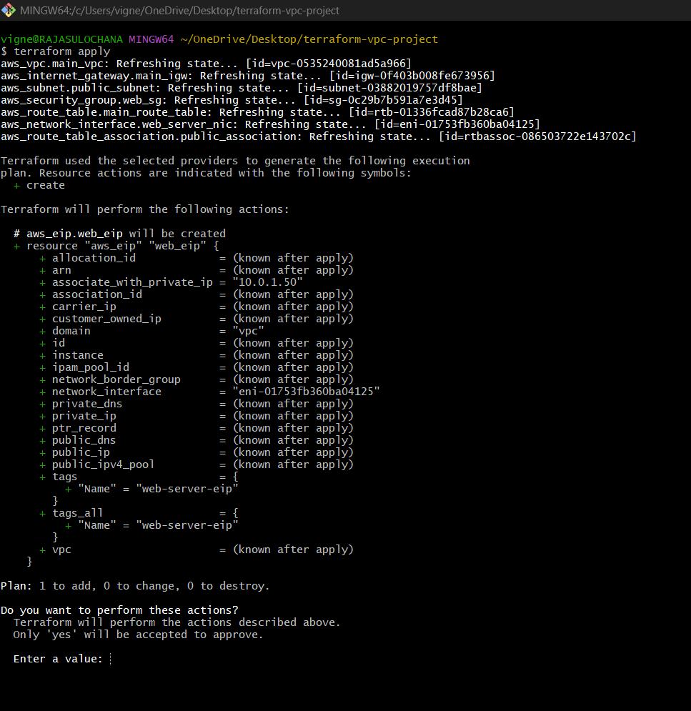

Do you want to perform these actions?
Type:
yes
Expected:
Apply complete! Resources: 1 added.
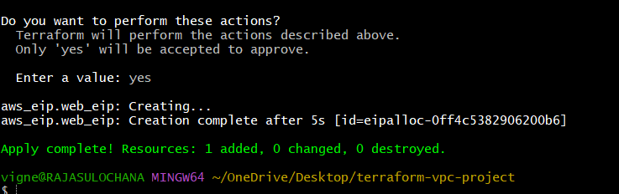

Step 8.6 — Verify in AWS Console
Open:
AWS Elastic IP Console
Navigate:
EC2 Dashboard → Elastic IPs
You will see:
web-server-eip
Details:
Property | Value
Public IP | 13.x.x.x
Private IP | 10.0.1.50
Network Interface | web-server-nic

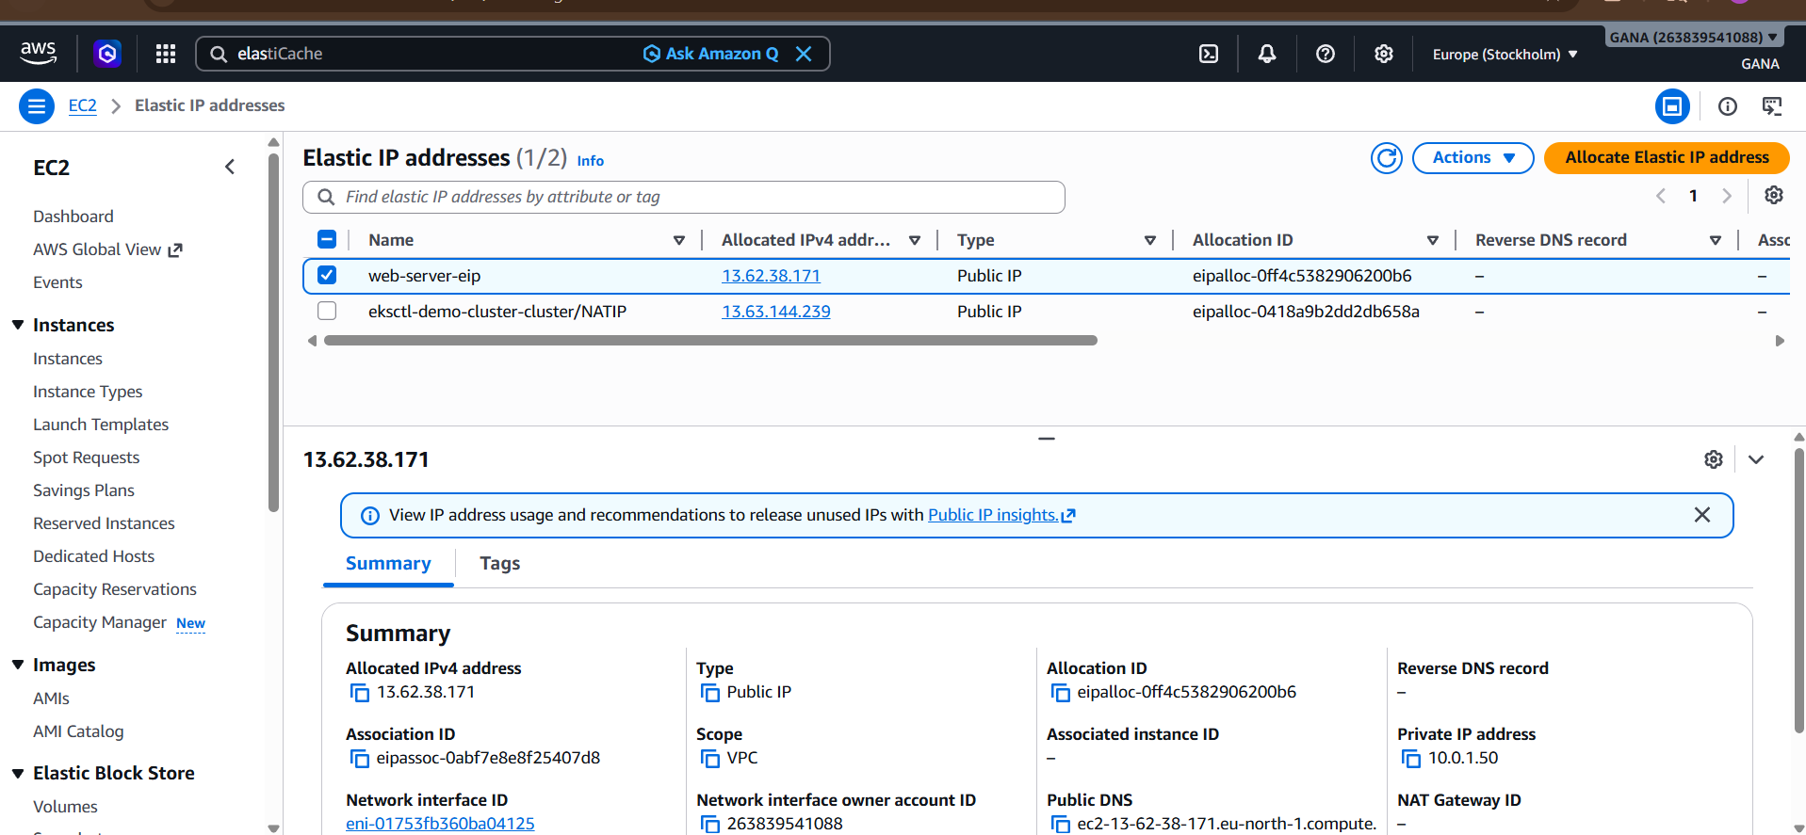
Updated Project Structure
terraform-vpc-project/
│
├── provider.tf
├── vpc.tf
├── igw.tf
├── route-table.tf
├── subnet.tf
├── route-table-association.tf
├── security-group.tf
├── network-interface.tf
├── elastic-ip.tf
├── terraform.tfstate
└── .terraform/

Infrastructure So Far
VPC
├── Internet Gateway
├── Route Table
├── Public Subnet
├── Security Group
├── Network Interface
└── Elastic IP

Real-Time Example
Suppose:
You host website:
example.com
DNS points to:
Elastic IP
Even after EC2 restart:
✅ Public IP remains same
Without EIP:
❌ Public IP changes

9) Create Ubuntu server and install/enable apache2

Step 9 — Create Ubuntu EC2 Server and Install Apache2 Using Terraform
Now we will create:
- Ubuntu EC2 Instance
- Attach existing Network Interface
- Install Apache2 automatically
- Enable Apache service
- Access website using Elastic IP

What We Are Building
We already created:
- VPC
- Internet Gateway
- Route Table
- Public Subnet
- Security Group
- Network Interface
- Elastic IP
Now we launch:
Ubuntu EC2 Web Server
Step 9.1 — Create ec2.tf
Create file:
touch ec2.tf
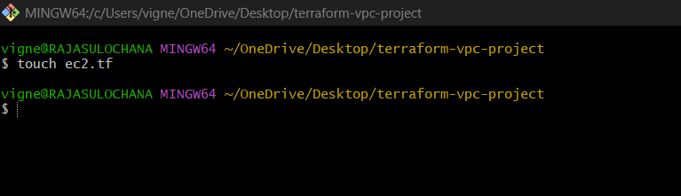
Open file:
code ec2.tf
Paste below code:
nano ec2.tf

resource "aws_instance" "web_server" {
ami = "ami-0b5a4e51202cd98e5"
instance_type = "t3.micro"
availability_zone = "eu-north-1a"
key_name = "ansible"
network_interface {
device_index = 0
network_interface_id = aws_network_interface.web_server_nic.id
}
user_data = <<-EOF
#!/bin/bash
sudo apt update -y
sudo apt install apache2 -y
sudo systemctl start apache2
sudo systemctl enable apache2
echo "<h1>Apache Server Created Using Terraform</h1>" | sudo tee /var/www/html/index.html
EOF
tags = {
Name = "ubuntu-apache-server"
}
}

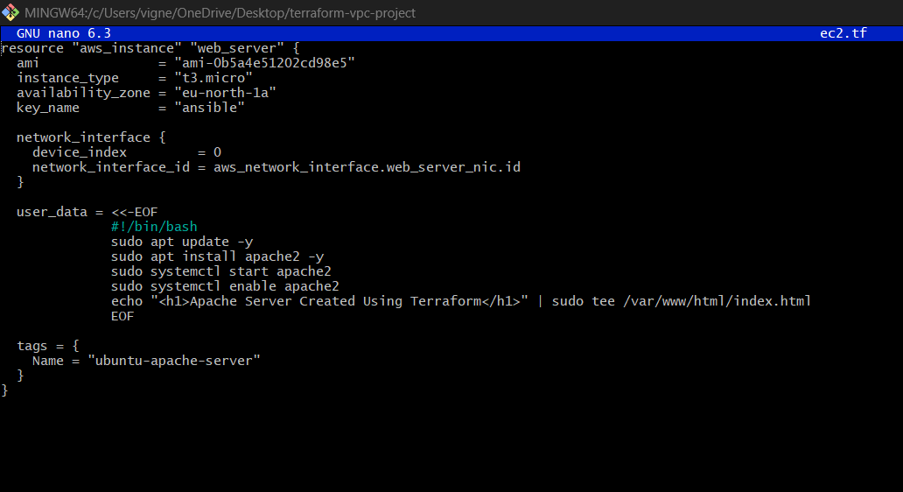

Important Before Running
Replace:
your-keypair-name
With your actual AWS Key Pair name.
Example:
key_name = "terraform-key"

Explanation
resource
Used to create AWS resource.
resource

aws_instance
Terraform EC2 resource type.
aws_instance

web_server
Terraform local resource name.
web_server
Terraform internally refers as:
ami
ami = "ami-0f58b397bc5c1f2e8"
Ubuntu AMI for:
Mumbai Region

instance_type
instance_type = "t2.micro"
AWS Free Tier eligible instance.
Specifications:
Resource | Value
vCPU | 1
RAM | 1 GB

availability_zone
availability_zone = "ap-south-1a"
Must match subnet AZ.

key_name
key_name
Used for SSH login.

SSH Access Flow
$$SSH→Port 22→EC2$$

Understanding network_interface Block
network_interface {
Attach existing ENI to EC2.

device_index = 0
device_index = 0
Primary network interface.

network_interface_id
network_interface_id = aws_network_interface.web_server_nic.id
Attach:
web-server-nic
to EC2 instance.

Network Flow
Elastic IP
↓
Network Interface
↓
EC2 Instance

Understanding user_data
user_data
Runs shell script automatically during EC2 startup.

Apache Installation Script
Update packages
sudo apt update -y

Install Apache2
sudo apt install apache2 -y
Installs:
Apache HTTP Server

Start Apache Service
sudo systemctl start apache2

Enable Apache on Boot
sudo systemctl enable apache2

Create Custom Web Page
echo "<h1>Apache Server Created Using Terraform</h1>"
Creates webpage.
Step 9.2 — Format Terraform Files
Run:
terraform fmt
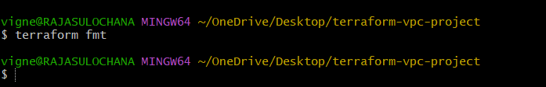

Step 9.3 — Validate Configuration
Run:
terraform validate
Expected:
Success! The configuration is valid.
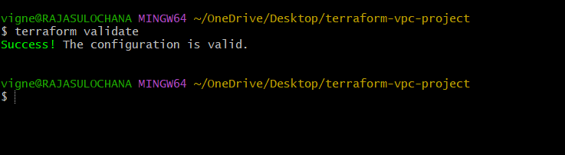

Step 9.4 — Check Terraform Plan
Run:
terraform plan
Expected:
Plan: 1 to add, 0 to change, 0 to destroy.
Terraform shows:
+ aws_instance.web_server
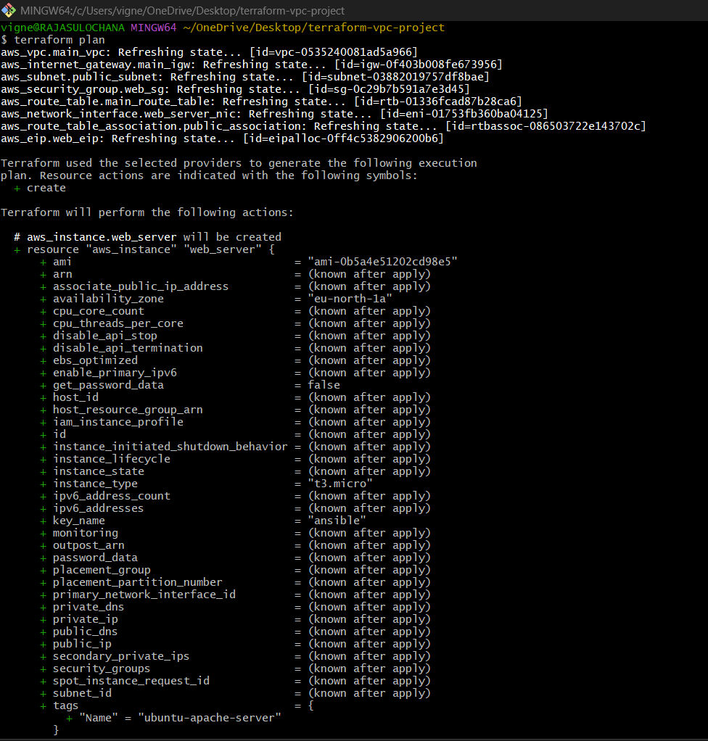
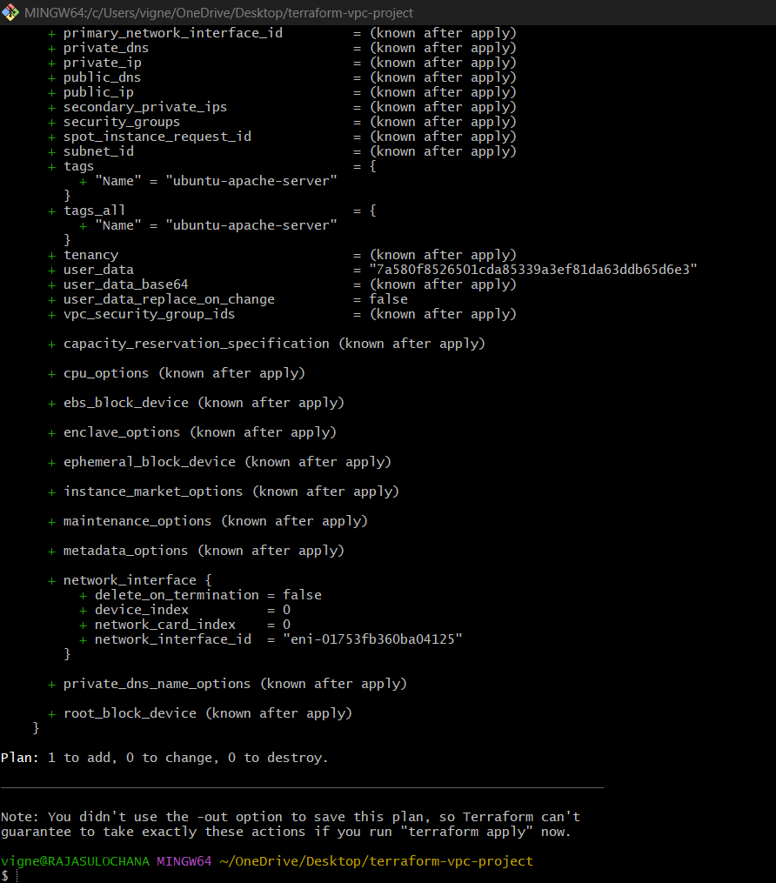

Step 9.5 — Apply Configuration
Run:
terraform apply
Terraform asks:
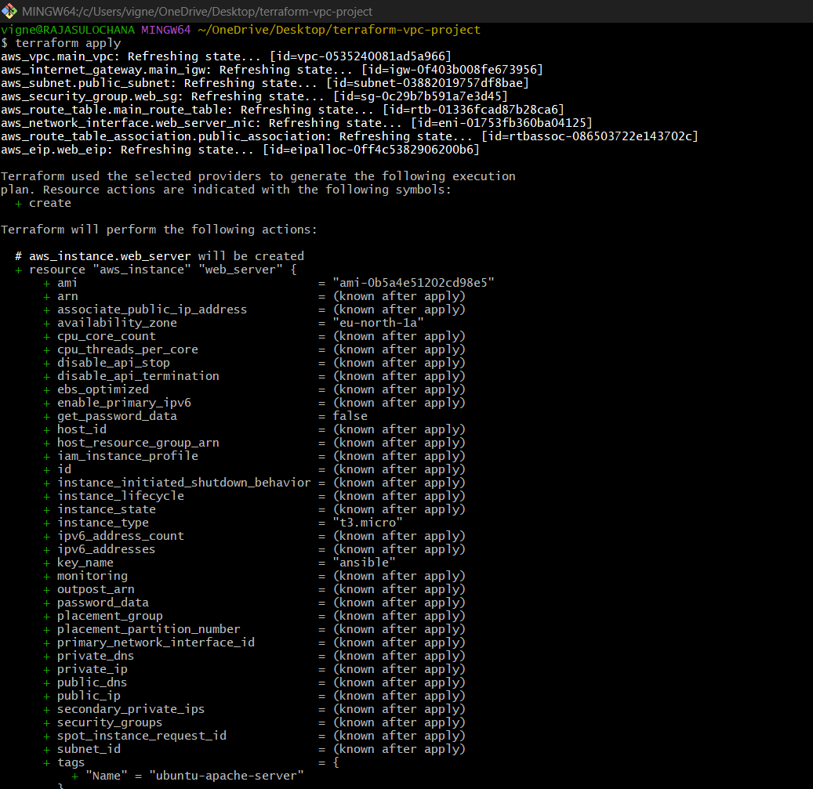
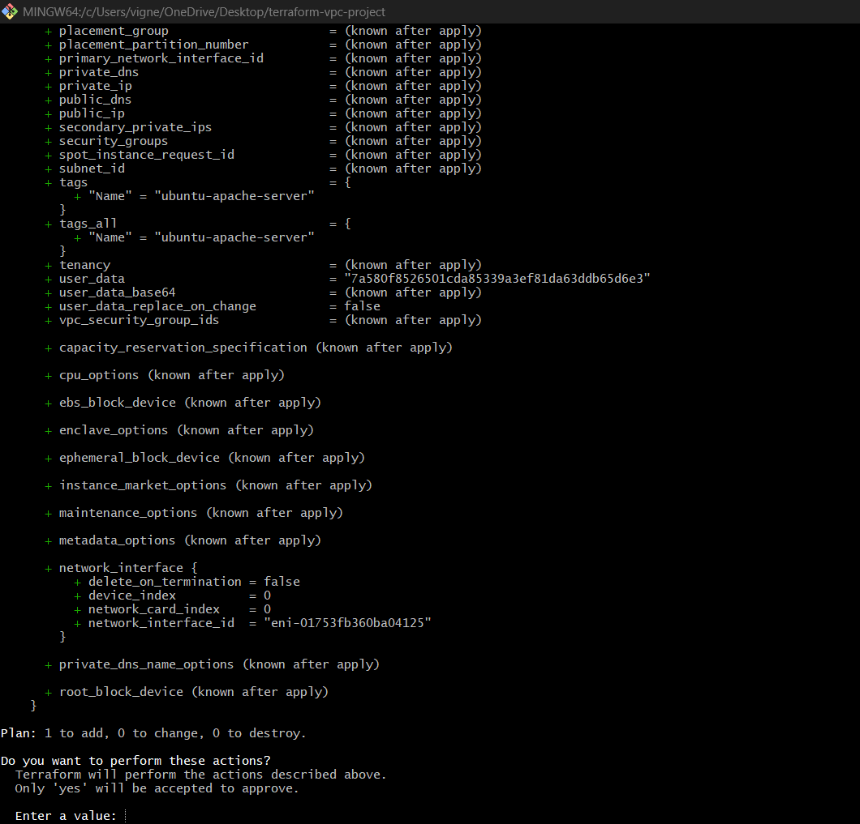

Do you want to perform these actions?
Type:
yes
Expected:
Apply complete! Resources: 1 added.
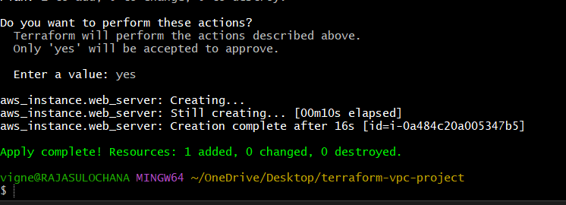

Step 9.6 — Verify EC2 in AWS Console
Open:
AWS EC2 Console
Navigate:
EC2 Dashboard → Instances
You will see:
ubuntu-apache-server
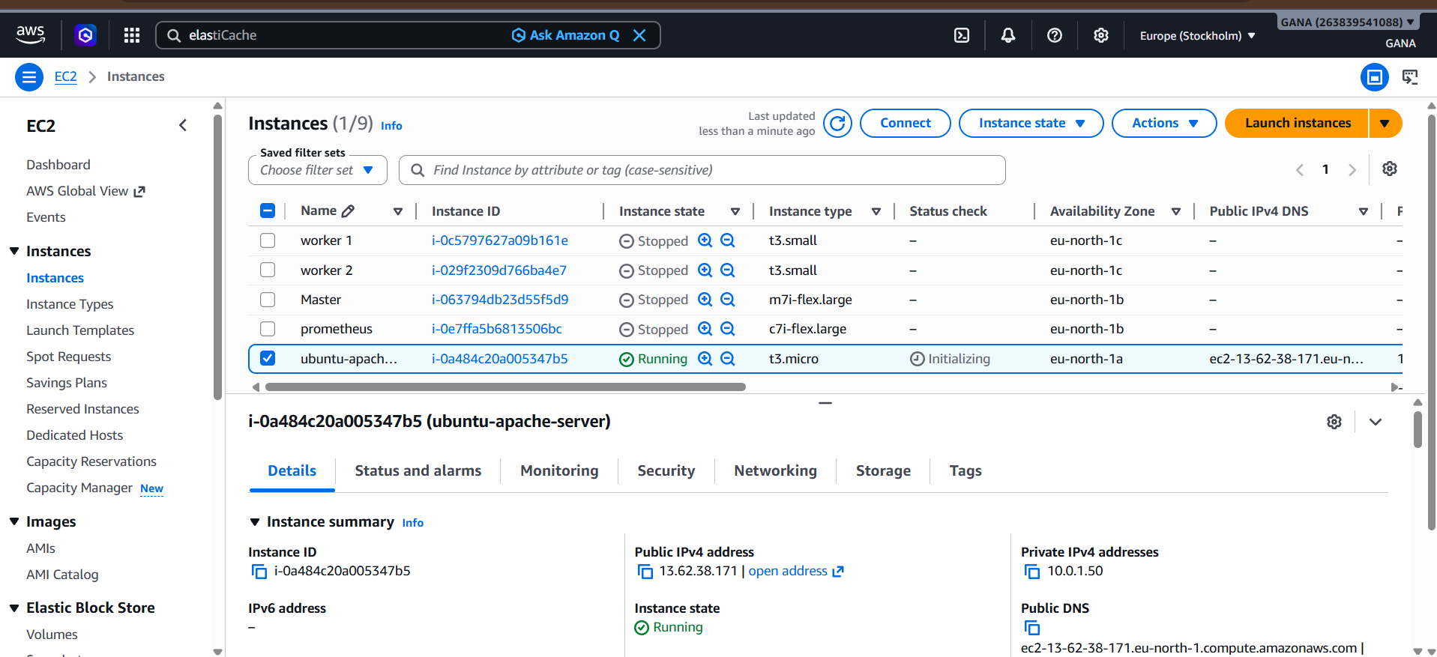

Step 9.7 — Access Website
Open browser:
http://YOUR_ELASTIC_IP
Example:
http://13.x.x.x
http://13.62.38.171/

Expected webpage:
Apache Server Created Using Terraform
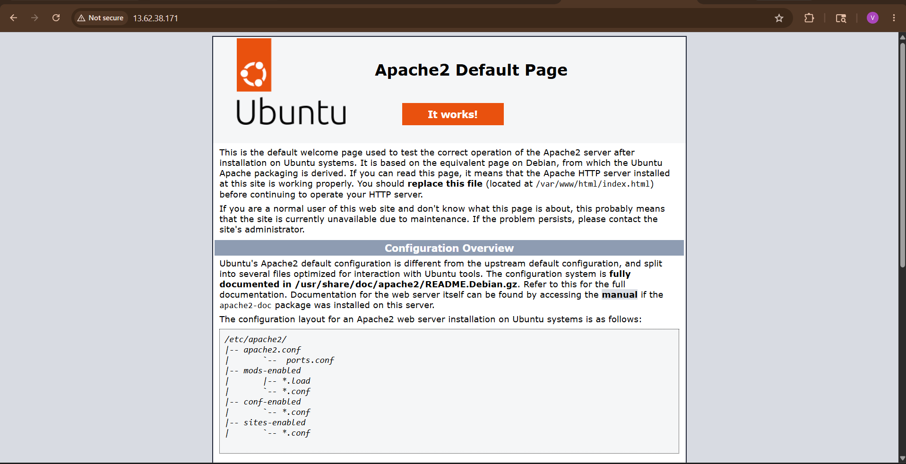
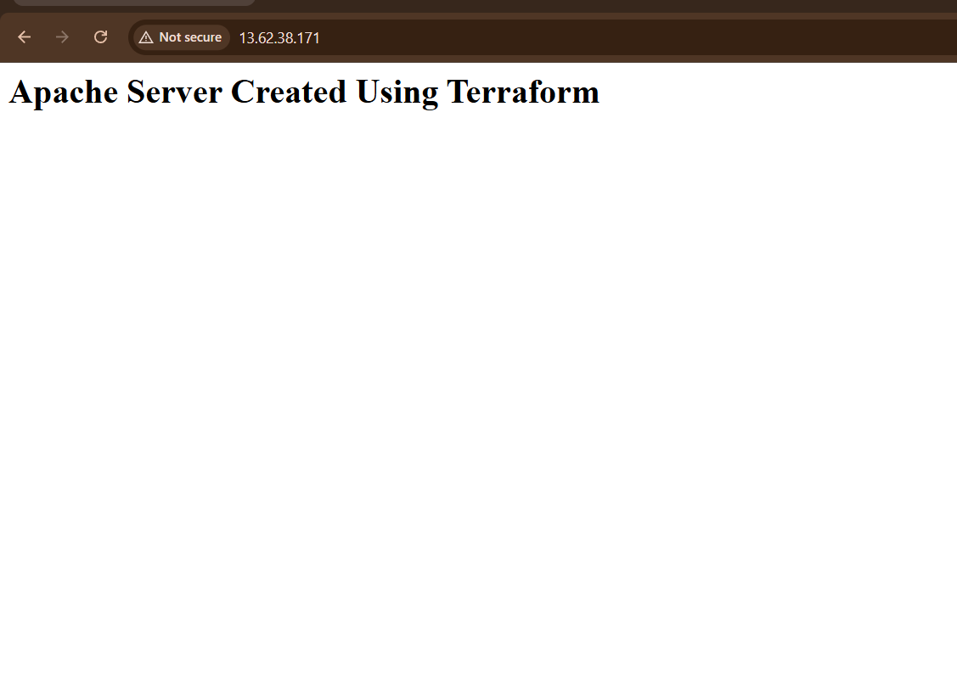

Step 9.8 — SSH into EC2
Command:
ssh -i your-key.pem ubuntu@YOUR_ELASTIC_IP
Example:
ssh -i terraform-key.pem ubuntu@13.x.x.x
ssh -i ansible.pem ubuntu@13.62.38.171

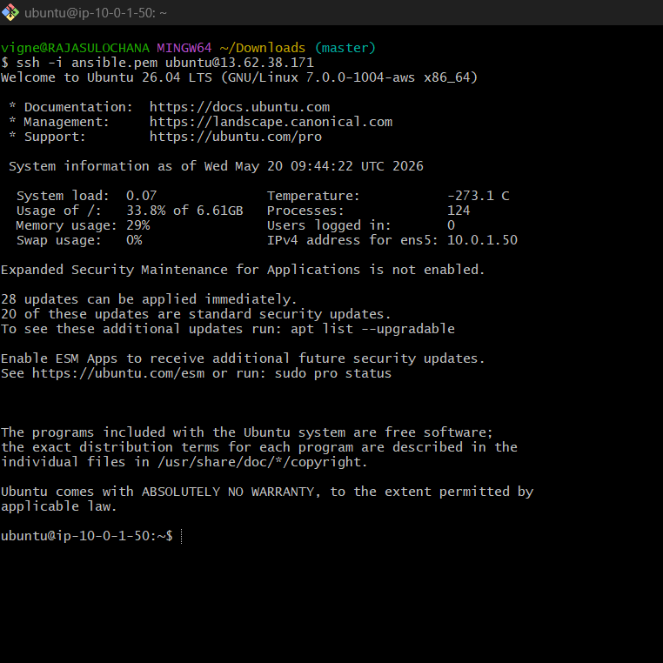

Verify Apache Status
Inside EC2 run:
systemctl status apache2
Expected:
active (running)

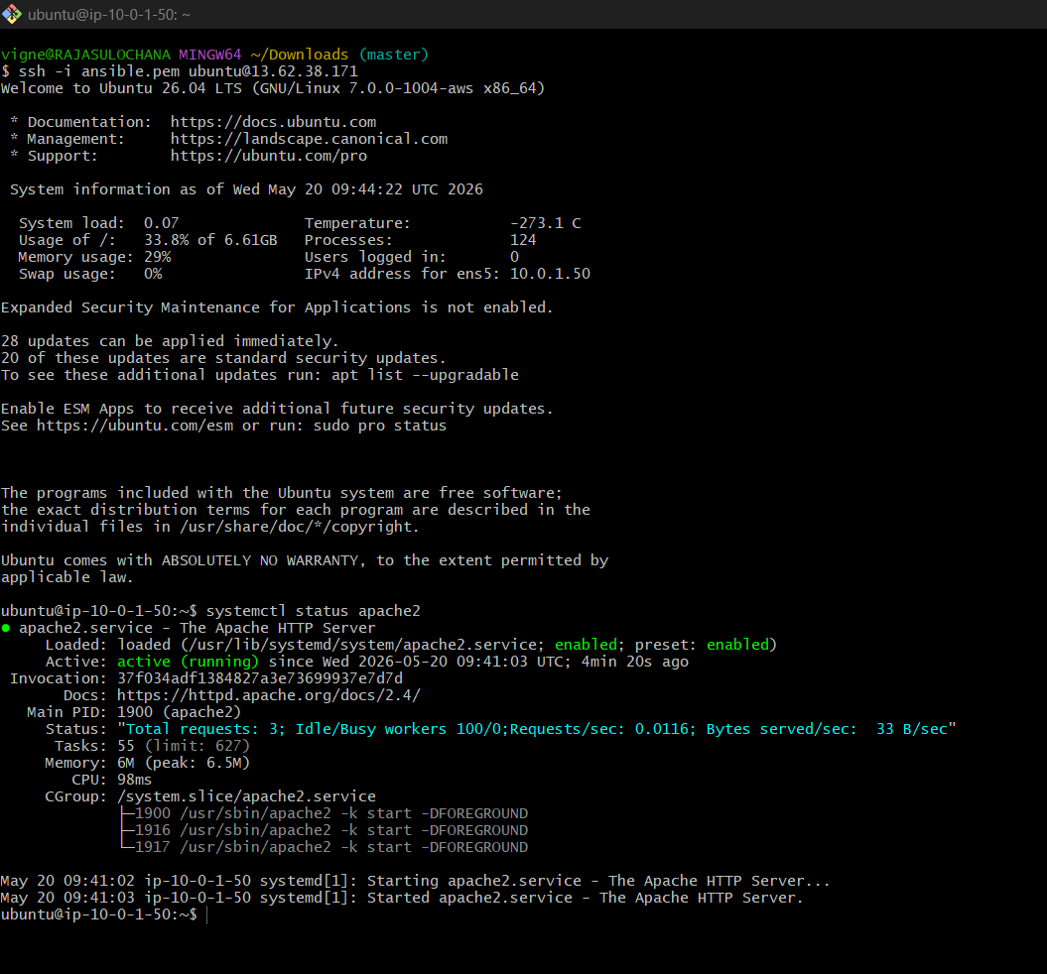

Updated Project Structure
terraform-vpc-project/
│
├── provider.tf
├── vpc.tf
├── igw.tf
├── route-table.tf
├── subnet.tf
├── route-table-association.tf
├── security-group.tf
├── network-interface.tf
├── elastic-ip.tf
├── ec2.tf
├── terraform.tfstate
└── .terraform/

Complete Infrastructure
VPC
├── Internet Gateway
├── Route Table
├── Public Subnet
├── Security Group
├── Network Interface
├── Elastic IP
└── Ubuntu EC2
└── Apache2 Web Server

Real-Time Use Case
This setup is similar to:
- Hosting company websites
- Deploying applications
- Running Jenkins servers
- Hosting Nginx/Apache applications

Final Outcome
You successfully built:
✅ Custom VPC
✅ Internet Gateway
✅ Route Table
✅ Public Subnet
✅ Security Group
✅ Network Interface
✅ Elastic IP
✅ Ubuntu EC2
✅ Apache2 Web Server

terraform destroy
